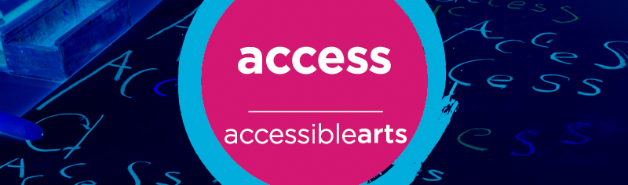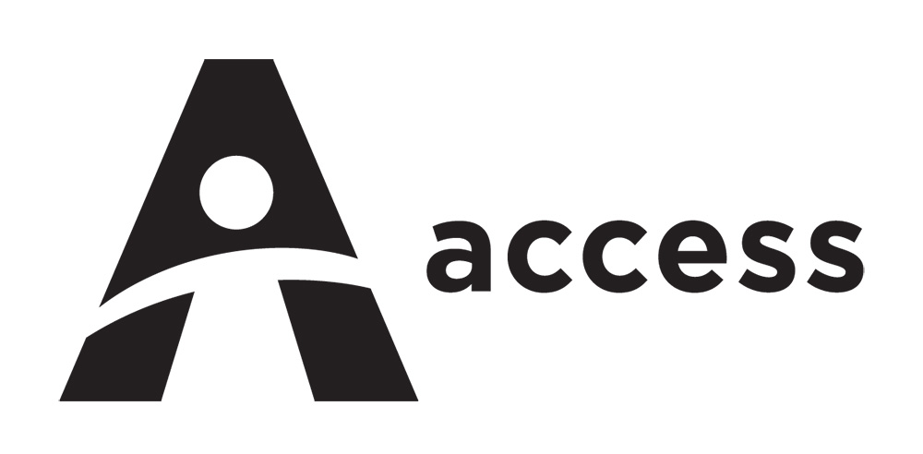

Press Invite and Media Release 24 February 2017

Join Disability Discrimination Commissioner, Mr Alastair McEwin, for brunch at the Sydney Theatre Company Bar, as he officially launches a world first initiative in the City of Sydney.

Accessible Arts in partnership with the City of Sydney warmly invite you to the public launch of the Accessing Sydney Collectively - ASYD.CO campaign. Designed to enable greater access to the arts and cultural life of the City of Sydney, the print digital campaign collectively removes barriers online for people with disability through just one click.

At the launch, Mr McEwin will unveil a new Access Symbol that supports improved online access awareness, connectivity and navigation for people with disability. The Access Symbol will be found on the home page of twelve leading cultural organisations in the City of Sydney.

The campaign further delivers a free pocket guide to the City of Sydney local and visitor community. The pocket guide lists the inaugural participating organisations, and directs visitors with disability to current access programs and initiatives using the campaign short URL, ASYD.CO and braille.

Inaugural participating organisations include: Sydney Theatre Company, City Recital Hall, Maritime Museum, Museum of Contemporary Art, Belvoir, Sydney Festival, Sydney Writers' Festival, Art Gallery of NSW, Sydney Film Festival, Carriageworks, Australian Museum and State Library of NSW.

We encourage you to promote this City wide initiative to the local and visitor community and work with us to remove barriers online for people with disability.

When: Wednesday 8 March 2017, 10.30am - 11.30am
Brunch refreshment provided.
Please advise of any dietary requirements.
Where: The Theatre Bar, Sydney Theatre Company, Pier 4, Hickson Road, Sydney, 2000
Access: If you have any access requirements please include in your RSVP. The event will be Auslan interpreted and is wheelchair accessible.
RSVP by Friday 3 March 2017.
Press contact:

Tammy Brennan, Communications Manager, Accessible Arts
tbrennan@aarts.net.au
0404 532 575 or +61 2 9251 6499 ext 101

Accessible Arts promotes full inclusion, access and opportunities in the arts for people with disability through advocacy, education and information. http://www.aarts.net.au

This project is proudly supported by the City of Sydney and its Knowledge Exchange Sponsorship Program.

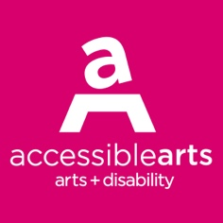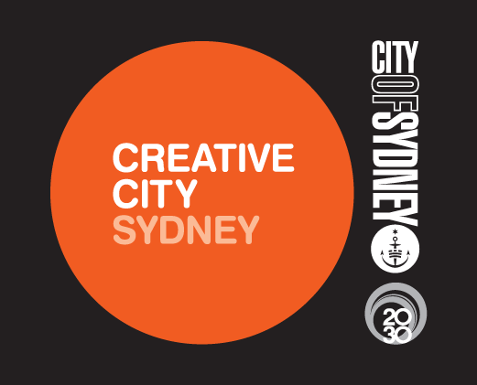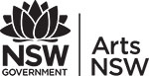

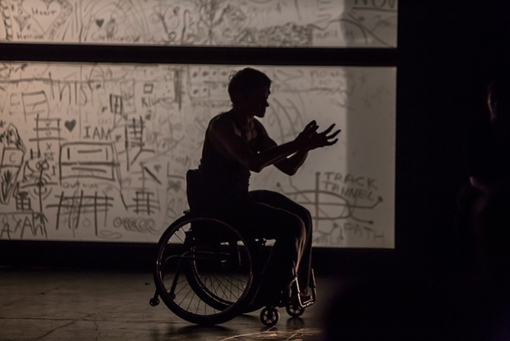

Image: Artist Matt Shilcock at Catalyst 2015, Carriageworks. Photo by Gisella Vollmer.

