Disability Inclusion Training 2017
Feedback and images

“I found the session great at opening space for opinions and discussion, and there was room for different values and views.”

“Thank you for providing this session. I am determined now to make some important changes within my organisation.”

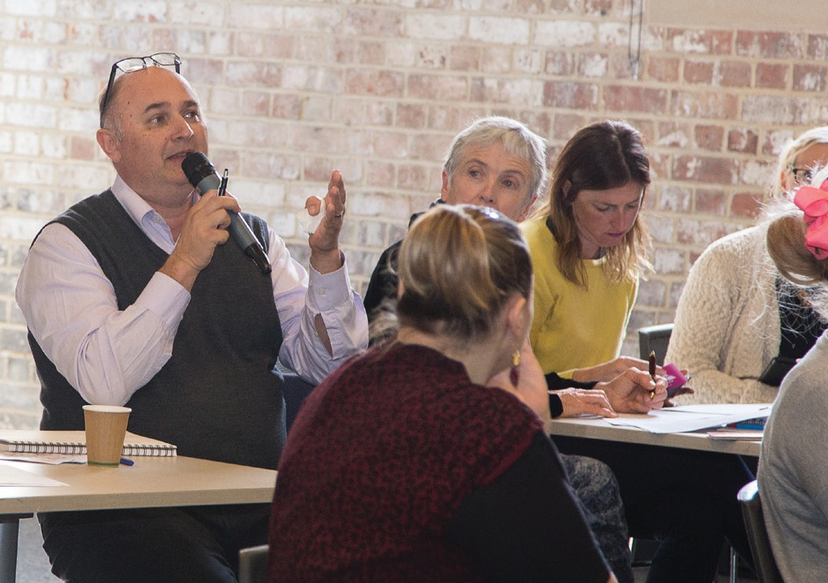

“A fabulous session which has made writing a DIAP seem possible! Thank you so much – really appreciate your expertise.”

“It was great to get a greater understanding of the history of activism and increased awareness of what else is out there to access in relation to information, policies and best practice.”

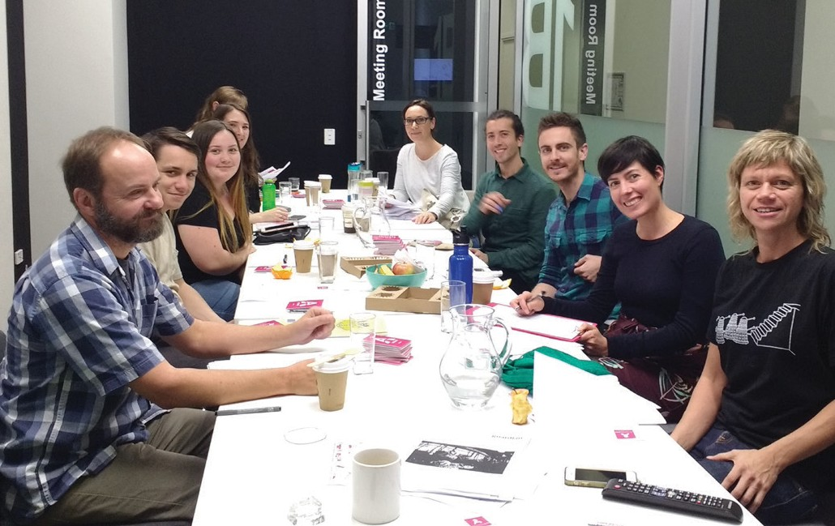

“I gained a different perspective on disability.”

“It really got me thinking about things that haven’t been on the top of my mind – from awareness tips, to how we can improve access, to language etiquette.”

“I love that the access training is done by people with disability.
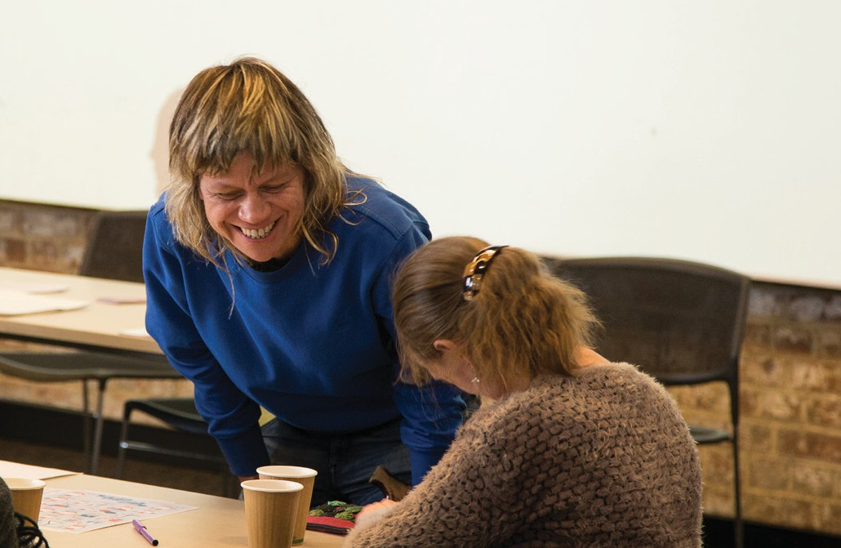
The first-person perspective is invaluable.”

