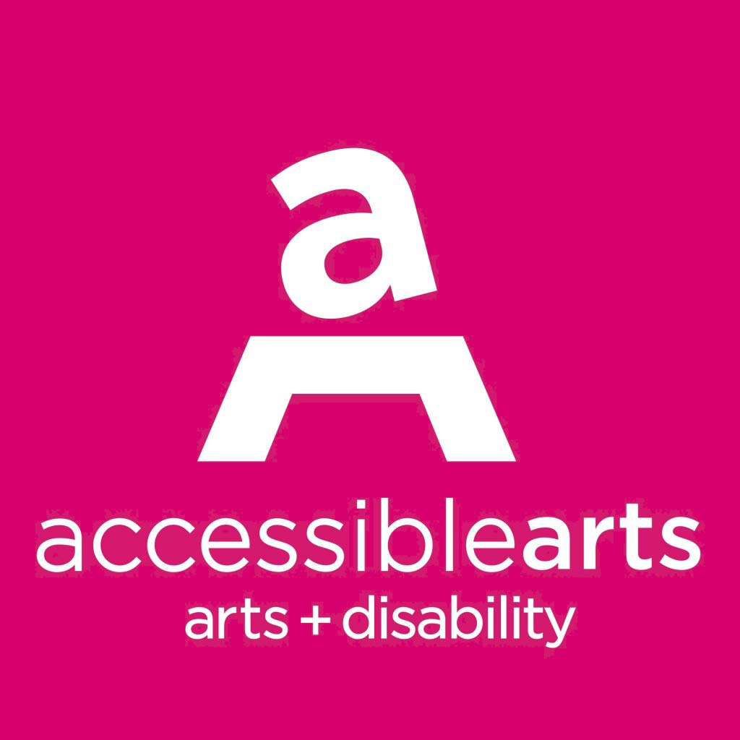

Accessible Arts
Position Description – Marketing & Communications Manager
Accessible Arts is committed to equity and inclusion, and welcomes applications from people from diverse backgrounds, including people with disability.

Details: Part-time, one year contract (three days per week)
Convenient location in the Rocks
Reporting to: CEO
Reports: Volunteer/s

Introduction to Accessible Arts
Accessible Arts is the peak arts and disability organisation in New South Wales. Our vision is excellence in arts + disability. Our mission is to provide leadership through information, advocacy and the facilitation of excellence in professional arts practice.
More information is available online at www.aarts.net.au.

Position Objective
The Marketing & Communications Manager is responsible for the marketing, communications, public relations, media and digital aspects of the organisation as well as maintaining relationships with all our stakeholders. Working closely with the CEO and other staff, this position will develop and implement strategies and plans to increase awareness of Accessible Arts and artists with disability across NSW.

Key accountabilities

1. Marketing, Communication & Brand
- In consultation with the CEO and all staff, develop and implement strategies to achieve Accessible Arts’ objectives;
- Undertake analysis of existing internal and external data to gain a better understanding of trends within the arts and disability sectors;
- Collaborate with all stakeholders to lead the promotion of and generate media opportunities for our consulting services, training, projects, campaigns and events;
- Manage all communication channels including websites, social media, monthly e-news, annual reporting, print and publicity (in accordance with our policies and accessibility standards, such as Plain English and Web Content Accessibility Guidelines WCAG 2.0);
- Oversee the creation, commissioning, production, acknowledgment, storage and legal protection of all publicly available content, including negotiating contracts with vendors and distributors;
- Managing all aspects of the Accessible Arts brand/sub-brands both tangible (our style guide) and intangible (our voice and values) across all channels;
- Guide all staff and other stakeholders in the use of Accessible Arts messaging, positioning and brand guidelines; and

- Evaluate communication tools on a quarterly basis, and report on KPIs as identified.

2. Fundraising & Grants
- Assist the CEO and all staff to develop and implement fundraising strategies, to achieve Accessible Arts’ objectives;
- Understand and reflect the needs of the organisation in all grant applications and fundraising campaigns;
- Assist the CEO and all staff to write funding applications and evaluate projects; and
- Oversee the collection of data, images, and other media from all projects in order to assist in monitoring and reporting.

3. Relationship Management
- Collaborate with the CEO and all staff to develop, nurture and strengthen relationships with government, philanthropic trusts, foundations, business and other stakeholders;
- Assist the CEO to build and maintain strong working relationships with similar arts and disability organisations in Australia and internationally; and
- Develop and maintain the Accessible Arts CRM database platform and build comprehensive profiles of all stakeholders.

4. Sector Consultation & Engagement
- Collaborate with the CEO and all staff to effectively engage with external audiences including artists with disability, arts and cultural organisations, donors, fundraisers, volunteers, businesses, researchers and others in creative industries;
- Actively source information about programs, projects, initiatives and best practice models available in the sector for publication and dissemination; and
- Build on your existing networks to develop broad industry connections to ensure all stakeholders are deeply engaged in the activities of Accessible Arts.

Other
- Assist with event production and logistics, including occasional evening and weekend work on an as-needed basis;
- Provide input and manage marketing and communications budgets and spend;
- Oversee contractors and volunteers as required;
- Present regular reports on strategic outcomes and activities to the CEO; and
- Contribute to organisational planning and strategy.

Key relationships
Primary liaison with:
- Internal stakeholders, including Accessible Arts staff and volunteers;
- Arts and disability artists and organisations;
- External service providers; and
- Media agencies.
Some liaison may be required from time to time with corporate partners, sponsors, event suppliers and venues.

Selection criteria

Essential
- High level skills and experience in strategic development and implementation of an integrated Marketing and Communications Plan (website, social media, live-streaming, video stories, fundraising) that drive awareness, engagement and social outcomes;
- Experience in the development, creation, management and delivery of print and digital collateral and campaigns across multiple communication channels, to a diverse audience using culturally appropriate and sensitive copywriting skills;
- Experience in sector consultation, relationship management and stakeholder engagement using digital database, communication and survey tools; and
- Collaborative, interpersonal style and the ability to interact positively within a small team.

Desirable
- Lived experience of disability;
- Knowledge and understanding of the arts and/or disability sector and accessible formats of communications (e.g. audio description, alt text, video captioning etc);
- Experience in a managerial role within an arts, or other not for profit organisation;
- Expertise in Search Engine Marketing (SEM), Search Engine Optimisation (SEO) and using data insights to drive strategy and enhance performance; and
- Experience using the following technology: Adobe Creative Suite, Wordpress, Filemaker Pro, Wordfly, Mailchimp, Crowdfunding platforms (e.g. Chuffed, Pozible, Start Some Good)

To apply:
Applicants must provide a covering letter specifically responding to the above selection criteria and a copy of their CV, including contact details of two referees.
Email to Kay Richardson, krichardson@aarts.net.au by at 9am on 4 December 2017.
If you have any enquiries about this position, please email Kay or call on +61 2 9251 6499.

Position description as at November 2017. This document will be reviewed on a regular basis and changes made to reflect changes in the requirements of the role.

