disability inclusion and access services

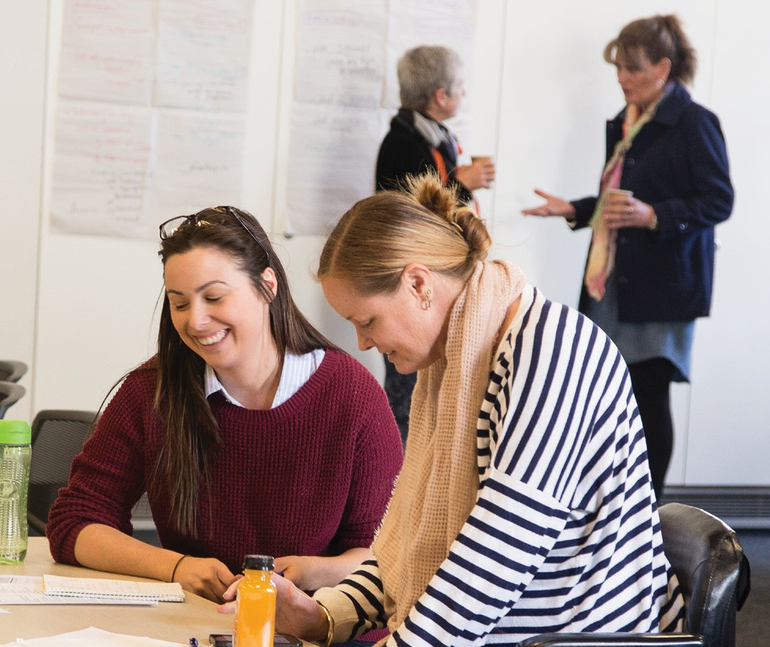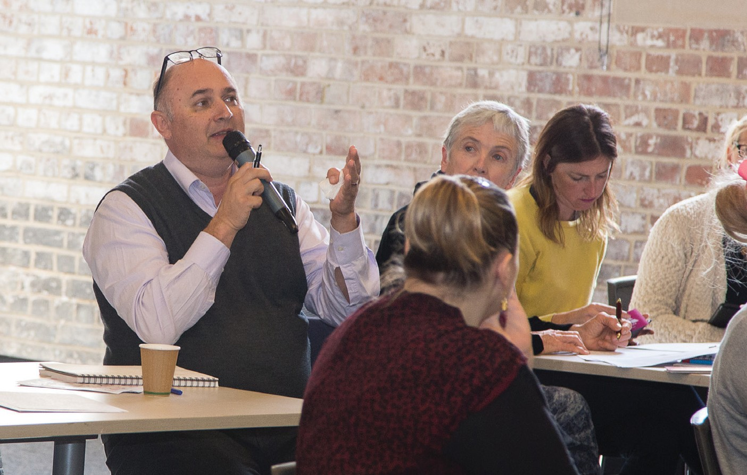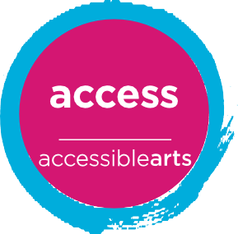Is your venue accessible and inclusive to people with disability?

Are your staff confident in communicating with people with disability? Do you need help with your Disability Inclusion Action Plan?
Photos: A disability inclusion training session in Newcastle, August 2017

Accessible Arts is a leading organisation when it comes to access and inclusion.
We promote opportunities for people with disability through advocacy, education and information. And we help organisations make accessibility a natural and integrated part of what they do.

How we can help you

- Disability Inclusion Training - general or tailored specifically to your organisation
- Workshops and consultation on developing Disability Inclusion Action Plans (DIAPs)
- Accessibility reviews of your policies, procedures, systems, websites and venues.
We also offer opportunities for professional development in the arts sector. This includes our Accessing the Arts (ATAG) network (free of charge) and Arts Activated, our biennial arts and disability conference.

Why choose us?
Having been the peak body for arts and disability in New South Wales for more than thirty years, we know our stuff.
Our trainers and consultants have lived experience of disability and/or are artists. This adds enormous value and creativity to our workshops and training sessions, which are original and fun. Participants bring their new insight, ideas and passion for access and inclusion back to their workplace.

“The training was engaging and helped our company learn more ways to improve and expand accessibility - within our team and with what our festival offers to the community.”
Skye McLennan, Ticketing Manager, Sydney Film Festival, 2017.

For more information and our rates visit aarts.net.au/access, email info@aarts.net.au or give us a call on 02 9251 6499.

The Arts Exchange, Level 3, 10 Hickson Road, The Rocks, NSW 2000
+61 2 9251 6499 | aarts.net.au

