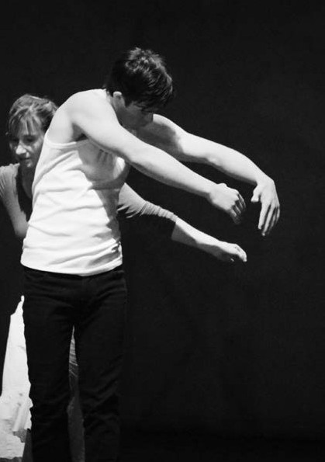

1

+ –

Positive/Negative
Writings on Integrated Dance

Positive/Negative
Writings on Integrated Dance

Accessible Arts acknowledges the support of the Ian Potter Foundation for the generous provision of funding to enable the Second and Digital edition of Positive/Negative writings
on integrated dance 2013.

Second edition:
Produced by Accessible Arts
Coordinated by Sarah-Vyne Vassallo Designed by Alphabet Studio Photography by Hayley Rose
ISBN 095783442X Accessible Arts would like
to thank the volunteers who
contributed to the coordination of this publication, Olivia Hutchison- Smith and Rebecca Canty.

First edition:
Concept Neridah Wyatt-Spratt
& Helen Connors Coordinated by Carey Lai Edited by Lynn Buchanan Designed by cercus Printed by Star Printery

Accessible Arts produced the first edition with assistance
from the Australian Government through the Australia Council for the Arts. In-kind support was also received from Ausdance NSW and Andrew Cornish.

© Accessible Arts 2000, 2013

Accessible Arts is the peak body for arts and disability in New South Wales, promoting full inclusion, access and
opportunities in the arts for people with disability through advocacy, education, leadership and information.

Accessible Arts is supported by the NSW Government through Arts NSW and Ageing, Disability and Home Care.

+61 2 9251 6499 info@aarts.net.au aarts.net.au

Contents

Foreword by Philip Channells 04

Introduction Andrew Morrish 08

Perceptions of Movement Neridah Wyatt-Spratt 10

The Dance of Disability Janice Florence 16

What’s Your Attitude? Working Towards an 22
Inclusive Dance Culture Jeff Meiners

Integrated Dance Workshop Stories Kat Worth 28

Restless Dance Company Sally Chance 34

Restless Dance Company checklist 44

Daring to Dance Ellin Krinsley 46

Flying Creatures from Man to Machine 56
Catherine Chappell

Dancing In, Over and Out Of Wheelchairs 66
Helen Clarke Lapin

Biographies 76

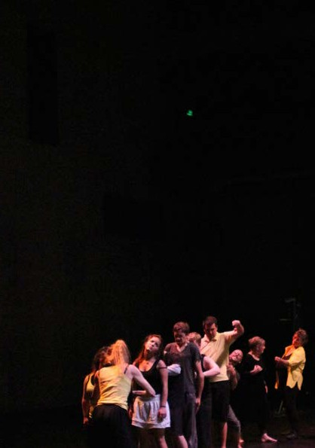

3

Foreward
Philip Channells

During the past two decades in Australia, social inclusion
in the arts has provided opportunities for participants living with a disability to engage meaningfully in programs that range across the art forms. In Andrew Morrish’s introduction he challenges the reader to
ask, “What is dance?”, “What is disability?” and “What is integration?” and since this first edition there have been many developments across the sector.

Significant opportunities have arisen for people with a disability to have their voices heard through the work of a number
of agencies and individuals. There has been ongoing support from the Australia Council and state-funding programs as
well as the dedication of peak body organisations such as Arts Access Australia (AAA). In addition, the work of all of the contributors to this publication
and many others not identified
in Positive/Negative, have played a role.

This activity has increased the visibility of people with a disability who are engaging in artistic endeavours, and has contributed to the cultural shift in our national identity. For the main part it
has promoted inclusivity and changed people’s perceptions of others living differently.

Organisations across the country that are working to increase access and participation for people living with a disability are:

• Accessible Arts (NSW)
• Art Ability (ACT)
• Arts Access Victoria
• Arts Action (Tasmania)
• Access2Arts (SA)
• DADAA (WA)
• Arts Access Darwin (NT)
• Arts Access Central Australia
(Alice Springs)
• Access Arts (Queensland).
For dance, in particular, there has been a steady growth in activity across the country. Adelaide-based Restless Dance Theatre (where I was Artistic Director 2009-2012) continues to develop its national profile while working in an integrated environment where young and
emerging and professional artists work collaboratively to create exceptional quality dance.

More recently, a spike in dance activity at Accessible Arts in
NSW has provided opportunities for people with and without a disability to access professional development in dance
through attending workshops, masterclasses and public forums. These projects include the Arts Activated Conference’s Beyond Technique – searching for authenticity workshops (2010), the Dance Symposium (2011) and the Catalyst Dance
Masterclass Series (2012, 2013).
As a result of this increase in activity we are now seeing many young people with a disability emerging from their teens and early adulthood contributing
to this cultural shift in dance. Exciting new relationships are being formed and continue to be nurtured especially through the ongoing work of Accessible Arts initiatives managed by
Arts Developemnt Officer for Performing Arts Sarah-Vyne Vassallo.

Various mentoring opportunities such as the JUMP Mentoring Program (Australia Council), Amplify your art (Accessible Arts), Kickstart (Next Wave Festival)
and the Junction Artist Exchange Program (Restless Dance Theatre) are several platforms from which emerging artists with a disability are taking the next step in their careers.

Since the 2007 collaboration between Australian Dance

Theatre (ADT) and Restless (Vocabulary – a double bill by Gary Stewart and Kat Worth with dancers from both companies), we are also seeing professional dance artists (without a disability) venturing into this area of dance and re-emerging, reshaping, redefining and adding to their practice exciting new directions for dance.

Since the first edition of Positive/ Negative, Janice Florence continues to work across dance- theatre and film while building
on the reputation of Weave
Movement Theatre. Through
her work with Melbourne-based artists such as Dianne Reid (Artistic Director Dancehouse
2004-2007), Michelle Heaven (who has danced for Balletlab, Chunky Move, Leigh Warren and Dancers, Lucy Guerin
Inc.), and Gerard Van Dyck and Kate Denborough (Co-creative Directors KAGE), Janice remains a key to the development of dance in Victoria. In addition,
UK-born dancer Jo Dunbar, through her association with Deaf Arts Network, has made a significant contribution through
Accessible Arts’ Deaf Can Dance program.
In Western Australia, a DADAA initiative has seen Paige Gordon (Artistic Director Buzz Dance Theatre 1998-2004) and
James Berlyn also explore new territory. In 2009 they founded TRACKSUIT and have added
to the changing landscape of Australian dance. Another mid- career artist, Liz Lea, Canberra Dance Theatre’s Artistic Director, has also ventured into this territory through facilitating the Integrated Dance Forum (2011) and making a commitment to
the weekly workshop programs, CDTeens and Jumping Moves, specifically designed for young dancers with a disability. Designer Gaelle Mellis received
a Creative Australia Fellowship through the Australia Council
to develop her own work, Take Up Thy Bed and Walk (2012). Sarah-Vyne Vassallo (DirtyFeet) has also ventured into this
area through The Right Foot Project and in regional NSW fledgling companies such as Studio Aperio (Murwillumbah), SPRUNG!! Integrated Dance Theatre (Alstonville), RED Inc. (Lismore) and Dis/assemble Dance Project, (Albury Wodonga) have had a considerable impact on their communities.
As one of the contributors to
the Catalyst Dance Masterclass Series,I have witnessed Sydney- based mid-career artists Sue Healey and Dean Walsh expand their creative practice to work more inclusively across dance, theatre and film. Catalyst marks a significant milestone in Australian dance as it achieves many successful outcomes through various levels of engagement
from all who contribute to it.

People without a disability often have the most to learn in this area of dance. Through my involvement in Australian dance over the past decade I have seen a more accepting view of “difference”, yet I believe that
as a sector we still have much work to do. Positive/Negative is a fantastic resource for dance education that shares diverse experiences from several key people who have contributed widely across the sector. For anyone new to working in an integrated dance environment, I recommend it as a must-read.

NB. Restless Dance Company changed its name since the
first edition of this publication to
Restless Dance Theatre.
Philip Channells is one of Australia’s leading experts in disability-inclusive dance
development. He’s the former Artistic Director of Restless Dance Theatre (2009 – 2012) and in the UK has worked with Candoco, StopGAP and Corali dance companies, Scottish Dance Theatre and East London Dance. Philip led the ‘Beyond
Technique Residency’, Australia’s first inclusive dance residency
at Bundanon Trust’s Boyd
Education Centre.

He’s presented his work at the Sydney Opera House, Judith Wright Centre for Contemporary Arts, Chaffey
Theatre, Ausdance Queensland, Ausdance Western Australia & DADAA WA, Ausdance South Australia, Ausdance Victoria’s Dance Your Heart Out, the Australian Youth Dance Festival, Accessible Arts’ Catalyst Dance Masterclass Series, National Dance Forum, Arts Activated Conference, Don’t DIS my ABILITY, Options Tertiary Dance Festival, Dance Symposium NSW & Carriageworks, Global
daCi/WDA Dance Summit Taipei, World Alliance for Arts Education Global Summit Finland and the Australia Week Celebrations in Port Moresby.

Introduction
Andrew Morrish

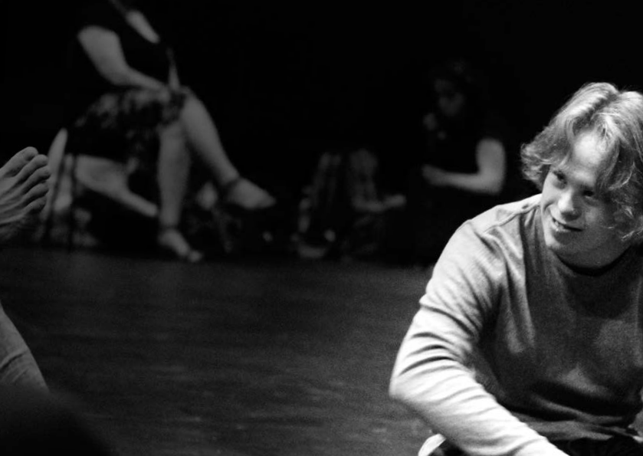
‘Reinventing the wheel’ is part of natural development in any field. For nearly twenty years I have been watching practitioners in the field of dance and disability finding and polishing their ‘own wheel’. The positive side of this
is a strong sense of ownership in their work. This is both laudable and desirable, but for a field to develop it needs to endorse both its oral tradition and to take the risk of making clear statements
of its own development.

Books such as Positive/ Negative become important markers for a field. We begin to realise there are things that have been said already, and that we can focus on what needs to be said next. They give us maps for pathways into the field and help us to recognise we are not alone when facing difficult situations.

Positive/Negative is intensely practical with the generosity of
its contributors evident in every chapter. They are giving us insights into both what they do and why they do it. You will find activities to explore, scenarios to ponder, and challenges to
your values on ‘what is dance?’,
‘what is disability?’ and ‘what is integration?’.

This book not only presents diversity in terms of population, it also clearly marks out diversity of the function of dance. There is reference
to dance for performance, self development, vocational opportunities, recreation and social development. This points directly at a history of dance that is much older than its contemporary manifestation
as a ‘performance art’ and, importantly, it points at why dance needs to claim back its own history in these broader functions. This is a radical view and it is heartening to find a
field in which the radicalism is profoundly based in compassion, competence and creativity.

I would like to congratulate and thank all the contributors for Positive and Negative
and to Accessible Arts for its initiative.

Perceptions of Movement
Neridah Wyatt-Spratt

When I was a child I wanted to grow up to be either a dancer or an archaeologist. Having
a sight disability from birth, I wanted to be the first dancer with a pair of specs on her
nose as she twirled through the air, my childish innocence and enthusiasm not yet aware of the aesthetics of dance. At age nine, after losing the sight in my right eye, my movement career was put on hold and I placed myself firmly within the world of ancient civilisations and cultures.

I still loved to dance, and through my teenage years and into adulthood I continued to take lessons in Australia and the United Kingdom. In 1994
I first experienced integrated dance in Australia and met Contact Improvisation teacher Helen Clarke Lapin. This led me to discover a dance form that gave me a sense of excitement and freedom that I had not
experienced since childhood. I had found my movement within improvisation.

Today I continue to explore and study within the improvisation area. In the past three years I have been teaching and co- teaching integrated movement to a diverse range of people. I
am also a member of Isthmus, a performance group comprising five women with disabilities who are exploring and developing aerial and physical theatre within movement performance.

Like many people who dance, I believe that everyone with or without a disability- can dance. I think one of the greatest failures of our society is that people
are compartmentalised and
that unconsciously people with disabilities are placed into the non-creative stream, thereby denying their creative potential.

As Project Officer for Accessible
Arts in New South Wales I
have been fortunate to have observed, participated in and taught many classes within a variety of arts practices.

Dance training can vary greatly depending on when a person acquired their disability and
their exposure to dance. A large percentage of people with a disability limit themselves to traditional forms of dance, if they dance at all. Moving beyond
the mainstream aesthetic of dance is the first hurdle. Finding classes and teachers who are open to including people with disabilities is the next step.

A simple fact: not every dance practitioner makes a good integrated practitioner. There
is a way of thinking and seeing that moves beyond the physical, a mental shift that for some comes naturally and creates an environment that facilitates the
reality of people’s desire to move.
Time is important, time to understand the language that each person brings to dance and time to understand how their language can become part of the whole. Whether solo or ensemble, integration requires the negotiation of an open dialogue between everyone involved. If you have little patience or do not listen, both literally and figuratively, then this may not be the practice for you.

The subtlety of disability politics is learnt through experience and time. There are no stereotypes; practitioners should have an open mind and treat people with
disabilities as individuals. Building a group sense is also important and the dynamics of a group can either make or break a creative process. If you are working with a mix of people in age and disability, it does help to have a person who knows the participants involved in the process.

The issue of safety, both physical and emotional, is extremely important. Having a regular class time and location creates a secure environment that everyone appreciates. Ensuring that only one person speaks at a time during discussions lessens confusion and encourages participation.

Allow individuals to identify their abilities and any issues that may affect the safety of the class environment. Recognise these and do not expect less than they are able to achieve. Expect all participants to give their best
and do not accept behaviour you wouldn’t regularly tolerate.
If you have a group that involves people who require support, then insist on it, or develop a volunteer system to provide the support.

Clarity in the direction you want to take and in the concepts that you
wish to work with is an important factor to consider when drawing up a workshop plan. Once people are familiar with you and your method of working then extend and push further.

What doesn’t work is a teaching structure that is rigid mentally and physically, and does not provide avenues for non-traditional
movers and performers to open up and explore.

For many years I attended
Sydney Dance Company
classes but felt that I never quite got the whole picture because
I could not see clearly. I would try to place myself behind someone who I knew was good, rather than ‘come out’ and tell the teacher that I had a sight disability. In hindsight this choice was wrong but I was young and didn’t want to draw attention to myself. Feeling exposed within
a class framework is a fear that most of us can relate to – for people with disability multiply that by ten. If you have a disability that people can’t help but notice then you are always a focus of attention. People notice those who use wheelchairs, sticks, guide dogs or who sign
or behave outside the ‘norm’. Those with ‘hidden’ disabilities may choose to remain hidden.

Most practitioners would be challenged if someone with obvious disabilities turned up
for a dance class unannounced. So what do you do? Don’t be put off by initial fear or panic;
this is a common reaction if you have limited experience with people with disabilities. Embrace diversity, take a deep breath and move on. I once taught a class which included
a woman whose only physical movement and communication
was to blink and smile. The class worked, but I was initially unsure how to include her in the group experience. This required her support worker to engage fully with the process. A great support worker is a bonus.

Making someone welcome without compromising the class structure is the key. As with
any new student, ask about their movement experience and what they can do. Never use
the negative. If you don’t have an issue with someone with a disability joining your class then the other participants should take their lead from you.

For people who find themselves in a class or performance with people with disabilities for the first time, yes, it can be scary. Everyone has similar concerns until they become confident and familiar.

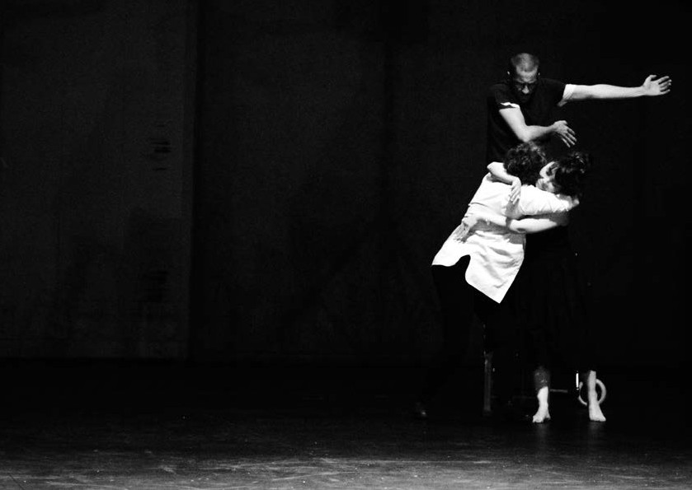
There are a number of reasons why improvisation as a training tool and performance mode
is appropriate for working and performing with people with differing abilities. Its technique and flexibility allows for and provides a freedom
of interpretation for both the participant and the practitioner, creating an equal playing field
for people with differing levels of experience. Improvisation opens up an avenue for communication, and dance provides an opportunity to communicate in a non-verbal way.

The notion of people with disabilities being part of a performance group is not new, but it is still rare. In Australia there are a number of individuals, companies and groups taking classes and
producing work but the public’s exposure to Integrated Dance is limited. To the people currently involved in Integrated Dance
will fall the task of being role models, leaders in the push for change, altering the ‘perception of movement’. We are proof that the potential can be realised,
that dance can be inclusive. It’s an exciting and stimulating place, the world of integrated performance, whether you want to be a teacher, participant or audience. Get out there, see what is happening and join in.

More information

View footage of integrated improvisation.

The Dance of Disability
Janice Florence

As a dancer who, suddenly
in a five-minute accidental fall acquired a permanent and major disability, I had no choice but
to expand my practice to make it inclusive of my new physical self. I was my first project. I began merely desiring to keep dancing, even if it turned out to be just a private practice. But my exploration was to broaden
in ways I never imagined. I came eventually to work with people with a broad range of disabilities and although I could apply some of what I had learned about myself, I found it was necessary to expand my ideas and my practice to encompass their individuality.

I was fortunate in being already thoroughly steeped in improvisational dance forms, which could be stretched and shaped to accommodate my own, and then other people’s diverse body states. More rigid
techniques may not have been as adaptable.

The aesthetic of ballet, a French court style of the seventeenth century, has been dominant
in forming the idea of what a dancer is and should be. Youth, attractiveness of a particular
kind, prescribed size and shape- ethereal, sylph-like- still inform people’s concept of the dancer. Even weight and age exclude people from this world. People with a disability certainly don’t
fit the mould. In addition, they would often find it impossible to perform the steps basic to
ballet and to much contemporary dance technique.

The idea that someone with a disability might dance is often greeted with incredulity and this for me underlines how
narrow is the general concept of dance. On my way to perform
at an Arts Festival, the airport attendant looked at me with
incomprehension when I said I was going as a dancer. He kept maintaining that I must be a painter or a musician, despite my increasingly loud protestations to the contrary.

Not long after my accident a teacher told me that I must accept that I would repulse some people who saw me perform. It is hard to move unselfconsciously with this thought in mind.

Under these circumstances I intensified my search for a new aesthetic. I use the word
intensified because even before the accident, I had not measured up in conventional dance terms.
I was far too tall and too well endowed with hips and thighs.

In the USA there are mixed ability dance companies, tutus and all, which pursue the ballet aesthetic. I am not comfortable with trying
to force people into an image or a style that is not authentic
to their physical state. I am not interested in putting them in a situation, which depicts them as falling short of the desirable norm. This is a position too frequently imposed on people
with disabilities in many aspects of their lives. Instead, I am interested in encouraging people to explore and extend untapped movement potential. People
with a disability have not been encouraged to become aware of the physical and expressive range that might be available to them, or to have a positive relationship with their physical selves. This is partly through
a reluctance to allow them to take risks and partly due to a perception of them as physically grotesque in relation to what is considered ‘normal’.

After my accident, I returned to dance through Skinner Releasing classes. Joan Skinner was originally a dancer with

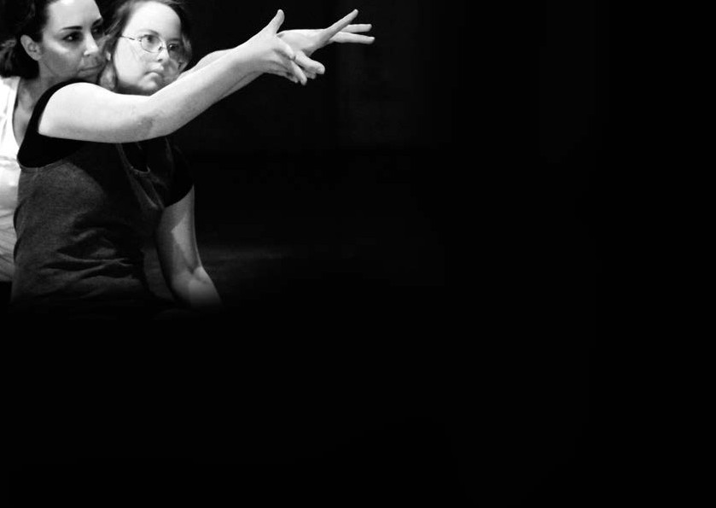
Martha Graham. After sustaining a dance injury, she began to search for a new approach to dance which would not damage the body. Her technique works through developing awareness
of body and movement through poetic natural images in the context of the body, as well as movement tasks and ‘graphics’ where desired directions and sensations are gently traced on the body with a partner. Then one moves with this awareness. Unexpectedly wonderful things can result. One learns to move
in ways that don’t lead to injury and damage. Movement seems to come from a more deeply integrated source.

I also discovered Contact Improvisation – a dance form which began in New York
in the 1970s, developed by experimental young dancers looking for a way of dancing which was more organic and
authentic to the human body, one that was an immediate and unexpected outcome of a
dance partnership. This led me to the forming of a small dance company called State of Flux, which consists of myself, Martin Hughes and three other able bodied dancers.

Aspects of Contact Improvisation, such as the exchange of weight, the use of counterbalance and resistance, give momentum and added versatility to a dancer
with a disability. It also allows
for an interchange between the partners, so that neither partner dominates, but each is influenced by the other.

It is a radical thought that an able- bodied dancer, representative
of the dominant paradigm, might willingly take on the movement of a dancer with a disability. Once the blinkers of convention are removed, there is a whole new world of dance
and choreographic possibility. In State of Flux, sometimes all dancers take to the floor and move as I do. At first I found this confronting. I think I am finally beginning to develop a taste for it.

In 1997, Martin Hughes and I were hired by Arts Access to teach a 12-week course to a group of people with various physical and sensory disabilities. This was an opportunity to
apply what I had learned about myself. It was a mixed group, also containing people without official disabilities. There were varying amounts of dance experience, from highly trained to nothing at all.

Some needed much work to get ‘in touch’ with their bodies and their movement resources. Some were entirely new to
the idea of improvisation. We made use of solo bodywork and improvisational structures, non-contact group tasks and
light physical contact. Having someone so close and in physical contact is confronting and even threatening for many people. People with disabilities, particularly, often experience unwelcome invasion of their personal space, even when it is well meaning.

In addition, the physical condition of some participants meant that for them, too much weight bearing was out of the question. In all our classes we stress the need for people to guard their own safety and to be assertive when something
is uncomfortable. As well as
light contact, we tried to provide flexible structures where people could experiment with more weight giving and taking if
they wished. People with disabilities are often over protected against risk.

Gradually a form began to emerge which seemed characteristic
of the group. As there was a wealth of experience within the group in drama, verbal and vocal skills, we began to incorporate those – again mainly in an improvisational framework. The group persisted and became Weave Movement Theatre. Finding low-cost, accessible studios with accessible toilets has always been a preoccupation.

As the group was taught from the beginning by someone with a disability, the ensemble has always been based on a highly integrated ethic. It is full of intelligent, experienced and
strong-minded individuals both with and without a disability. Each has taken teaching roles and have devised and directed pieces. I am not advocating that this is the only way to operate. Sometimes people
with disabilities seek a respite in
separateness. They may crave
an opportunity to make their own decisions and create their own aesthetic. I have sometimes felt out of place in a dance class full of able-bodied people, especially when they are uncomfortable
with my presence.

However, the integrated ethic, which has evolved in ‘Flux’ and
‘Weave’, gives opportunities for everyone to expand through their continuing dialogue and makes for a varied pool of movement resources. Segregation has often been a way of not taking artists with disabilities seriously, of placing their work in a separate category and treating their work patronisingly as ‘therapy’. Indeed art can be therapy for many
kinds of people and it can be a community art experience. However, having people with disabilities involved does not automatically put it in these categories.
Recently, I have also been involved in projects with people with intellectual disabilities. While there has been much in common with my other work in the dance and movement ideas employed,
I found that I needed to change my style of communicating to some degree. I was used to working with fairly complex mental concepts; now I explored further the value of conveying ideas in concrete images and in
increased use of demonstration. I also had to curb my tendency to cram too much into a session.

Veering between the categories
of ‘community’ and ‘professional’
has been a constant tension for Weave. If people with disabilities are involved, there is an automatic urge to dub the project ‘community’, but some of our members with disabilities are highly trained and very experienced.
Others are not. Thinking in some sections of the arts community is stuffy and restricted and would dismiss the idea that people with disabilities could aspire to the status of professional.

Perhaps we need to allow more fluid categories. Diverse people should be included, not deterred from dancing. They may also emerge as leaders, teachers
and artists. In other words they should be allowed the range of potential more readily assumed to be the right of the rest of the community.

More Information

View footage of a State of Flux improvisation session.

View footage of
Weave Movement Theatre.

What’s Your Attitude?
Working towards an inclusive dance culture. Jeff Meiners

In Sydney in the late 1990s Helen
Clarke Lapin made a plea for
‘a more inclusive dance culture, one that would embrace a wide range of body types, ages and abilities’. On the other side of the world, Adam Benjamin wrote that ‘Integrated Dance can offer a useful model for the rest of the dance world’. Both calls resonated with me. I was working freelance, having just
moved from England to Australia, and my work in the dance world involved me in the development
of an inclusive dance culture that addresses attitudes to the dancing body.

Integrated Dance is a practice that sees people of wide-ranging abilities working together with artistic concerns for both dance process and product.

Experience tells me that Integrated Dance can foster a change in attitude for both participant and observer.
I have seen leading arts and education policy-makers and funders moved and provoked into new ways of thinking about art, artists, dance and
the human body; and watched professional dancers of high repute connecting to bodies and minds they never expected to work with. An experience
of Integrated Dance can shift fundamental beliefs and lead towards a new valuing of body types and abilities. On a personal and public level, it challenges deeply embedded aesthetic values, forcing participants to question personal tastes and preferences about dance and bodies, confronting beliefs and prejudices learned from parents and families, the surrounding culture and exposure to the
global media.

Working with Integrated
Dance projects requires first
a willingness to embark upon
a journey into often-unknown territory in partnership with others who are quite obviously different from oneself. As we acknowledge a shared desire, intentions can become clearer and a mutual commitment to
learning established. An essential element of such projects is
time – time devoted to detailed planning, review and evaluation. Good communication is also fundamental to the working process, and should not be
left to chance. Communication needs to be facilitated through active reflection so that the participants are open to sharing their hopes, expectations and concerns for the project.

Good facilitators are often also good teachers. They establish a safe teaching and learning environment in which participants respond to and resolve exploration and problem- solving tasks. These facilitator/
teachers use their imaginations to ‘get inside the heads’ of the participants, identifying individual participants’ skills, motivating them with relevant ideas and material, and encouraging active and creative quality contributions in the artistic process.

My early dance study led me to a project with deaf students through the Laban Centre in London. As a student teacher, I was intrigued by deaf students’ lack of confidence when integrated into ‘mainstream’ classes, in sharp contrast to
my observations of them in the schoolyard where they articulated enthusiastically with each other. Aware of their highly sophisticated visual and kinesthetic abilities in communicating with each other,
I wondered how they might dance together. This provided a springboard for other projects.

Empowering participants became a crucial theme and, with Newham Dance Team, I led

sessions for young people with Downs Syndrome, with severe communication difficulties, in a language unit and in a project that linked a ‘mainstream’ group of primary students with disabilities.

Through Candoco Dance Company’s innovative education and community program,
I worked with a workshop program in Birmingham, which offered teaching students the opportunity to work with their peers in wheelchairs. First, after much lobbying and consultation, the university dance studio
was made accessible. Then funding for transport to the venue needed to be secured- a major challenge in project
planning. Some ‘students were anxious about working with people in wheelchairs, requiring considerable discussion about gaining and relinquishing control and power. All the students
evaluated this short program as a challenge to their thinking about the dancing body.

More recently in Australia, I worked with the 1997 Anybodies Dancing project, led by dance artists Helen Clarke Lapin and Janis Claxton exploring how integrated groups can work.
The project culminated in an informally presented collation of some of the work undertaken during the workshops, which was hailed by viewers as
‘challenging’, ‘beautiful’,
‘moving’, ‘thought provoking’
and ‘full of artistic integrity’.

A fundamental principle emphasised by both leading dance artists was the empowerment of all bodies through dance. Consideration was given to the working process, especially the need for
sensitivity, care and trust required by all participants due to the
wide-ranging needs and abilities
of the group. Knowledge of individual physical abilities was a key issue, requiring participants to share information honestly
so that risk-taking and safety – physical and emotional – could be balanced.

The project challenged conventional perceptions of the dancing body, each responding to technical and choreographic tasks by contributing their
own movement to the dance. Audience perceptions of traditional ‘theatre art’ dancing bodies were challenged and viewers were required to consider notions of beauty, aesthetics, validity, ownership, content and intent.

Questions and tasks focused on asking ‘what can we do?’ rather than saying ‘we can’t do that’. This required a high degree of flexibility from all participants, including the leaders. The dancers felt that they had
been challenged creatively and positively by working together to find solutions to movement tasks, often with unexpected and exciting outcomes.

Throughout the project, the open atmosphere engendered by
the two dance artists enabled concerns about accident and injury to be expressed honestly, as well as the sharing of information about participants’ particular physical conditions
in order to gain a better understanding of each person’s dance abilities and potential.

The pilot Sydney Children’s Hospital School Project began in 1999 and is running again in
2000, with Helen Clarke Lapin and myself, to provide access to dance for a changing population of children with physical disabilities, with IV poles, machines with plugs and tubes dangling, even children in beds.

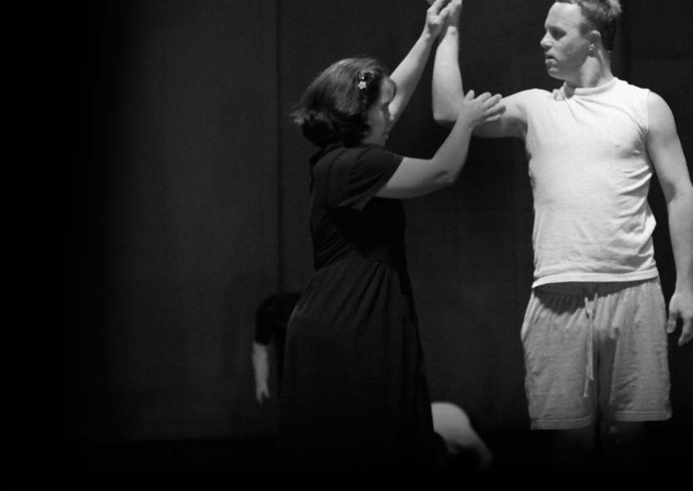
Our question was ‘How can we dance together in hospital?’.

At the outset, associated multi-disciplinary hospital representatives were consulted to ensure that clear aims were
established in the context of other hospital work. Consultation with doctors, nurses, physiotherapists, play therapists and clinical
nurse consultants ensures that relevant and up-to date information is communicated to the school staff. They can then brief the dance team weekly
on the medical condition and needs of the students. Staff workshops and longer meetings are also held regularly to deepen understanding of the aims and ensure that the project is properly reviewed with recommendations for future plans.

A major focus of the project
is to consider the potential of dance for teaching and learning in the hospital school context.
Key considerations include curriculum development in dance and the contribution of dance in supporting students’ self esteem, confidence and self-image in relation to their hospitalisation. The project has clear educational rather than therapeutic aims.

These provide;

a positive dance learning experience for hospitalised school students;

understanding the potential of dance as a learning medium and skill development for hospital school staff in teaching dance;

awareness and understanding of the potential of dance
for interested medical and therapeutic hospital staff, e.g. physiotherapists, psychologists, recreation and play therapists.

People gain access to dance through opportunities for
creative action and participation.
Integrated Dance in action demonstrates the potential of the practice to act as a catalyst for change and growth in the individual and the group.

Difference and the notion of
‘self’ and ‘other’ is intrinsic
to this work, often provoking major attitude shifts, with each participant considering themselves in direct relation to other humans with whom
they might not have otherwise worked. Integrated Dance
offers considerable potential for including and valuing individual contributions. It provides a foundation for considering
each part of dance activity
as crucial to a healthy dance ecology. Ultimately it is the responsibility of those leading dance development policy to ensure that this foundation is more accessible and includes opportunities for all those who wish to participate in dance.

Integrated Dance
Workshop Stories
Kat Worth

The most profound dance workshop I have ever been in was the most recent. It was my final class with Company CHAOS as their Director. We
danced the history of the group, imprinting historical landmarks through movement taken
from performances, projects, people’s coming and goings. This remarkable group placed me in the middle of their circle and graced me with intangible gifts and moving memories
of moments and years spent dancing, creating, performing, teaching, learning and playing together. As incredibly difficult as it has been to farewell CHAOS, this moment became my pinnacle of our involvement. I was leaving and they would
be continuing without me. The group had become so strong and independent in their own cultural practice that they
were able to determine their
own future. This is successful
Integrated Dance work.

Integrated Dance, although driven by disability dance, draws on the diversity, difference and union of dancers with and without disabilities, in cultural
and artistic collaboration in class, on choreographies, performance and project management.

People with disabilities have always danced, however there are now more opportunities
for them to be involved in professional dance. I have led Integrated Dance sessions in a variety of settings: regular classes, one-off workshops, guest company workshops, school workshops, teacher
training programs, information and discussion sessions, festival workshops, project direction
and choreography. Along the way I have learnt to stay flexible,
adaptable and never to assume anything. It is from the class,
the participants involved that I learn how to teach and how to include.

I had an interesting experience of an Integrated Dance workshop that challenged me to keep exploring communication options throughout the entirety
of the workshop. It was at the
1999 ‘Art & Soul Festival of DisAbility Art and Culture’ in Los Angeles. There was no registration for festival activities
so it was one of those ‘wait and see who comes’ events.

I had a chunky plan, a three- hour slot and no support. A large group from the Philippines joined -they turned out to be
a deaf theatre company who did not speak any English. The festival interpreter had to decipher what I was saying
in English and then sign it in
Filipino. I was glad we had three hours! I just couldn’t seem to get any information across. I was watching tasks being interpreted as something else and then
had even more difficulty in throwing them away in the hope of trying something else more successfully. Forgetting the class plan, I worked hard at splitting
up the Filipino company among the few other participants in the hope that the integration would smooth out the communication process. This worked somewhat and we seemed to enjoy some small group ‘over, under and around’ dancing.

It is the challenging workshops, such as this one, that have articulated my teaching abilities the most. The understanding
of the differences is what allows for the integration. As a dance practitioner it is exciting to work with such
individuality. Diverse dancers

create a diverse aesthetic. I have seen education departments approach integration as ‘we
want to integrate the special education kids into the normal school activities’ and even more commonly, ‘we want to do the reverse integration and have the normal students work/play with the students with disabilities’. Integration can be and usually is both ways at the same time.

I led a dance workshop with Company CHAOS at a high school in Lismore, northern New South Wales that wanted to integrate the special education students with the regular students. The school was well resourced with an accessible dance studio, a
full secondary dance program and highly qualified teachers. I was interested in their need for outside assistance. I still find it unusual that Integrated Dance
is seen as something specialist.
It is simply about dancing together.

The presence of Company CHAOS is strong and people are moved by seeing confident dancers with disabilities enter
a circle and strut their stuff. In this school there was a magic moment that I often see, where a dancer in a wheelchair first enters the circle and waits for the next person to enter and make a shape around them.
It seems like forever until one brave person thinks ‘what the heck’ and goes for it and your dance workshop has then become integrated.

It has been advantageous when introducing Integrated Dance to a new group to have some active support. The Lismore school’s workshop
was relatively successful largely due to the professional and experienced working team. There is no formally recognised
ID teacher training, therefore practical experience is the highest qualification. Through Company CHAOS, arts workers have been trained to teach Integrated Dance programs. In order for it to be the accepted norm that dance classes are inclusive and accessible to all people, teachers require the skills to practice inclusivity. They need to become confident to accept all bodies and minds
into their classes trust the participant or support person to disclose special needs, and have some knowledge of how
to adapt ideas, terminology and techniques.

Even with the above skills a teacher can never cease to learn. I led a one-hour class for
10-16 year olds with various disabilities at a sport and recreation camp. I prepared the usual questions: ‘How many kids? How many teachers?
How big is the hall? Music? Skill level? Needs?’. The answers seemed workable and I thought
I could handle it. It was an unusual time of 7.30pm which didn’t help me at all when
it came to communicating with fifty or so kids with developmental disabilities, two teachers and the care workers and ‘other’ kids running, jumping and playing around the hall. It is times like these you wish you had your professional support team! I shouted and I
drummed, rang my stilling Indian chimes and attempted mid-
class conference with the two teachers who were giving one- on-one support. I had well and truly given up my lesson plan. The only time the screaming and running stopped was with Madonna, so Madonna played and I just followed the leader, each one of them until we wore each other out. The only thing

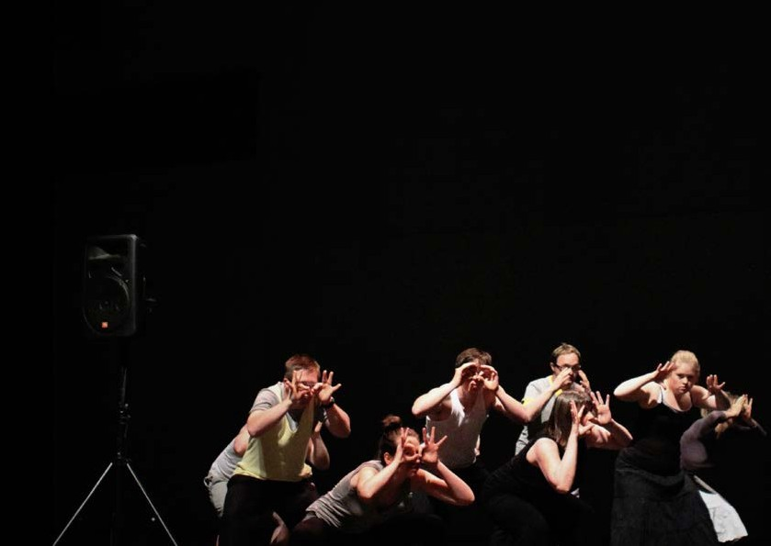
that worked in this class was that I stayed and stuck it out.

The consistent training and ongoing development of Company CHAOS members has produced Integrated Dance workshops with a mature professional standard and
high level skills base. The level at which the core company’s Integrated Dance artists are able to work has achieved quality performance material and renowned success.

A project of such quality was
‘In the Name of Love’ in 1999. The project explored sexuality, intimacy and relationship. In addition to workshops and rehearsals were family planning workshops, movie watching,
lots of talking, social outings and a major performance season. Company CHAOS has up to thirteen core performers but
for this project only eight were selected to perform. This was because those eight were highly experienced in their work as employed professional dancers and were mature enough to manage the content of the piece through performance.

An important aspect of
the project was that it truly emphasised the skill of the dancers involved. Each dancer had a completely individual sexual education and life experience. There was no normal. There
was no common denominator. Each dancer had stories to share and secrets to keep. The
workshop process covered deep and personal issues and was challenging and educational.
The final piece was performed with integrity, professionalism and outstanding calibre. It is artists such as these whose accumulated skill opens up
workshops to limitless exploration of improvisation, composition and collaborative choreography.

It is important to acknowledge the culture of disabilities, which Integrated Dance work stems from, and the intrinsic skills
that are specific to Integrated Dance practice. I ask you to consider the need for dance to be all inclusive, but at the same time to recognise and make advantageous the individual
skills and styles by remarking and drawing on the differences rather than comparing or evaluating them. The classes I have led have included all types of disabilities and often have
an indefinable mixture within the one class. Disabilities, as with human beings, are most individual and my aim as an Integrated Dance practitioner is to include any body who walks, wheels or crawls into my class.

Hope to see you in a workshop some time.

More Information

View class and workshop footage of Company CHAOS.

Restless Dance Company
Sally Chance

The atmosphere was electric.

In August 1991, for one night only, ninety people with a disability and a small band
of their carers and recreation supporters filled the Norwood Concert Hall in Adelaide. The dances represented the raw material of future work: complex solos, some totally unplanned; small groups stepping boldly into the space; large group pieces which needed to accommodate some performers deciding at
the last minute whether they wanted to perform or not; the Aboriginal social group/ from one of Adelaide’s large residential institutions for people with an intellectual disability/ stomping their stuff to music by Yothu
Yindi- all presented under huge ceiling-to-floor banners designed by some of the participants in separate visual arts workshops.

This performance marked the culmination of a Carclew Youth
Arts Centre community dance project called MOC Connections
– a precursor to Restless Dance Company. Since those beginnings Restless has grown to encompass:

• A youth performance ensemble, involving up to twenty people aged 15-26 with and without an intellectual disability
• A professional ensemble, involving five experienced dancers with an intellectual disability
• Community cultural development projects, involving people of all ages in dance programs exploring the culture and identity of people with a disability.

When I founded the company in 1991, I was motivated simply by a sense of social justice, of redressing the historical imbalance of dance not being available for people
with a disability. I wanted to demonstrate that people with a disability could make dance too.

Right from the start the company has worked with people with and without an intellectual disability
to create dance theatre and run community dance workshops in which the dancers with a disability are the driving force. Encouraging the dancers with an intellectual disability to gain a genuine sense of their skill level is a continuing issue for the company.

In the first year of his involvement with the youth ensemble one of the dancers would refer to the
‘teachers’, meaning everyone without a disability. He had internalised a sense of having a lower status than people who were actually his peers and whose role in the company he shared. Even the experienced professional ensemble members tend to defer to the ideas of people without a disability.
Collaborators without a disability are deliberately positioned as guests of the group, in order
to encourage the professional ensemble members to take their own skills seriously.

The tendency among people with an intellectual disability to play down their own expertise needs to be gently redressed at every level. It is common in community dance contexts for support workers to change during the program, due to changing staff rosters and other demands. This can undermine the progress of
a participant, who defers to the new staff member’s approach to the workshop, even though
the person with a disability is the more regular participant. Projects work best with continuity of staff involvement- the integration
of people with and without a disability can be modeled by staff members taking part in the workshops in their own style.

Support people are partners and allies in this important work. Mutual respect between
support staff and the workshop leader is as essential for a successful project as building positive relationships with the participants.

As a means of demonstrating the expertise of people with an intellectual disability, we use a team of co-leaders who work alongside the workshop leader in
the company’s community cultural development programs. The early days were a huge challenge, because it took a long time to find out who could handle the role and even longer for those people to develop their skills.

My valiant colleagues and
I wondered for a long time whether we were setting up a token role for the co-leaders, whether the sheer challenge of involving them in the ebb and flow of the workshop served
only to undermine them, and whether we had the energy to sustain the double role for us of running a group as well as finding ways in which the co-leader
could meaningfully take some responsibility.

Over time it has all been worth it! The co-leaders have come to operate as powerful role
models for other people with an intellectual disability, demonstrating their expertise and supporting participants to recognise their
own developing skills.

In the early days of the company
I described the methodology that evolved in the work of Restless
as ‘reverse integration’. My use of the word integration took a term familiar to the disability sector- the principle that every person with a disability has the right to integrate into society, enjoying equal access to work, education, relationships, religion and politics – and then turned it on its head.
Nowadays, disability sector policy has shifted to embrace a model of personal empowerment and the need for people with
a disability to make their own choices. I like to think that Restless has always operated this way, but the initial concept
of reverse integration was useful. Reverse integration referred to
the idea that the dancers without a disability entered into an activity that they did not automatically own. In other words, they were the people having to do the integrating and find their place within a ‘normality’ defined by the others. They became the ‘other’.

Material for a performance evolves from the dancers’ personal responses to improvisation tasks devised by the director. These ideas
are then shaped, modified and positioned by the director in collaboration with the dancers. The dancers agree on the ‘right’
and the ‘wrong’ of the imagery in relation to the ideas they want to express. However, in performance there is always room for the subtle shifts of
pacing or spacing by which the dancers with a disability make the material their own. If the dancers without a disability hold on to material which had earlier been ‘right’ then they are wrong, because they are not paying
attention to the constant creation and re-creation of the work, ‘in the moment’.

In this way, the work of the dancers without a disability is about much more than
‘accommodating’ the dancers with a disability or ‘working around’ their idiosyncrasies. It is about tuning into ways of being in the world, which respond to mood and imagination rather than logic and intellectualising.

The notion of reverse integration placed the dancers without a

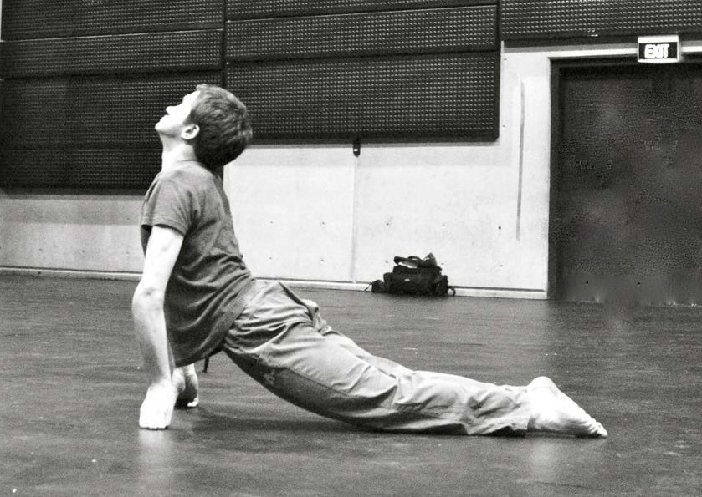

disability into a situation more usually experienced by the dancers with a disability. More interestingly though, the idea challenged the assumption that a young person with a disability would necessarily want to be more ‘normal’ by benchmarking their way of dealing with the dance workshop against the responses of the people without a disability, or to play down the
qualities and style that they have
because of their disabilities.

Reverse integration as our working methodology did not disregard the drive in every person to fit in and be accepted, nor did it ignore the emotional
and practical challenges faced by young people with an intellectual disability in other spheres of
their lives. Its main focus was to establish a creative space, in which having an intellectual
disability was advantageous and in which young people with an
intellectual disability, with their intuition, idiosyncratic creativity and highly individual dance languages, could excel.

Our thinking started to shift in an exciting way when one of the dancers with a disability began to talk about cultures of disability. This was articulated in terms of unique ways of speaking and thinking. These wonderful concepts freed up the thinking behind the work
to become far more complex than the earlier notion of reverse integration. It is dynamic and positive, rather than defining itself in terms of what it is not.

The disability culture model recognises that professional artists or community arts participants with a disability need to have their art viewed as art in its own right and not just as disabled art. In fact the
company’s work had to achieve a certain amount of critical
acclaim from audiences, arts colleagues and funding bodies in order to have the appropriate credibility to pursue the thought process of cultures of disability.

Another major shift was the realisation that the emphasis on the performers with a disability risked alienating the performers without a disability, whose involvement in the company has always been a key aspect of the company’s success. Ironically, the dancers without a disability faced the kind of marginalisation that the company seeks to redress on behalf of people with a disability.

I now feel that successful Integrated Dance work depends on providing separate talk space for the dancers with and without a disability to articulate their own perspective, particularly if the distinction between the roles
of dancers with and without
a disability is not marked with
payment or other indicators. The dancers without a disability are now invited to meet regularly in a separate group to air everything from practical ways
of supporting the dancers with a disability to in-depth discussions about the company’s aesthetic and ways of maintaining our disability-driven ethos.

An exciting development scheduled for the youth ensemble next year is a new work which makes use of screen culture as a manifestation of youth culture. The dancers
without a disability wanted to feel that their peers with a disability were prepared to meet them halfway along the disability
culture youth culture spectrum rather than expect them to do all the travelling into their culture.

For me the whole notion comes full circle because the power
of the attitude of the dancers without a disability lies in the

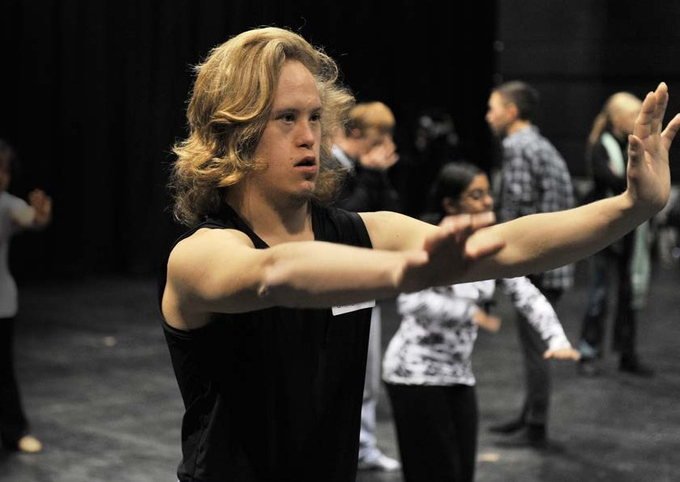

demands placed on their peers with a disability. Far from setting up the sort of space that we have worked to avoid over the years, in which the dancers with a disability struggle with their
‘dis’-abilities, the context now being created by the dancers without a disability requires the dancers with a disability to take responsibility for the direction of the company and forces them to make use of their power if they are truly to be the company’s driving force.

We have travelled a long way since that August night at the Norwood Concert Hall. The work’s demands and rewards make you want to settle in for the long haul, because it’s a fascinating journey.

More Information

View footage of Restless Dance
Company.

Restless Dance Company’s
Checklist for Support Workers

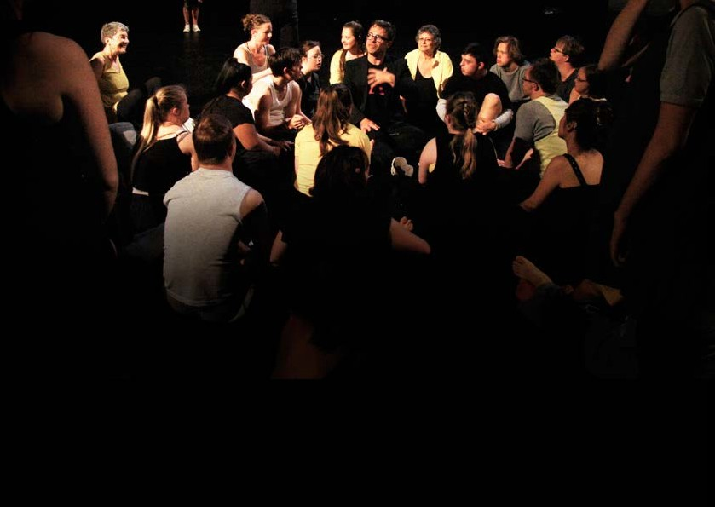
• Participate as yourself as far as possible.
We hope that you enjoy the workshop too! Your clients ideally need to experience the workshop alongside you. Your open, relaxed involvement validates the dance activity for your client. We are generally not happy to have people watching the workshop because this
says it’s OK not to participate. (Regular group members are, of course, welcome to sit quietly for a while.)
We are open to arranging certain occasions during the project for people to watch. This may be at the end of the whole project, or for the last ten minutes of each week, or at the halfway stage.
• Designate prior to the workshop who will specifically support whom. If someone needs support during the workshop it needs to be provided within the group or by leaving the group for a short while with the person in that designated
role for the session. This is to ensure the continuity of the workshop.
• Your participants are the experts.
People with an intellectual disability are often experts in an activity such as a creative dance class because of their ability to improvise and follow their own ideas. Supporters need to acknowledge this
and tune in to the movement
vocabulary the group is developing, particularly if
they have missed a couple of weeks of workshops because of the staff roster or other circumstances.
• Develop a sixth sense for when to provide support and when to leave space. This is to do with the ‘right’ and the ‘wrong’ of the workshop being decided on by the participants. People are only going ‘wrong’ if they are hurting or interrupting other people.
The actual movement does not have rules to do with set rhythms, steps, right/left or use of the room. Creative dance does not aim for everyone
doing the same move at the same time. It’s more to do with creating the same mood as
a group or sharing the same moves but performing them in your own time.
• Enjoy the workshops!
Feel free to ask the workshop leader any questions or to feed back any worries or thoughts you may have.
We aim to balance our experience in creative dance with your knowledge and understanding of your clients with their interests and ideas.
A dance project is a dialogue, in which we value the input of everyone involved.

Daring to Dance
Ellin Krinsly

Please join me and together we will enter into a world of movement and storytelling that steps beyond the boundaries
of what most of us imagine is possible. Weemala is an extended care facility that provides residential care for people with severe physical disabilities. The residents in my classes have a range of movement possibilities -some are in a coma, some have no movement but can smile and make eye contact, some can move an arm, leg or fingers.

For most people, dance and expressive movement is for
the fit, active, coordinated and young. I believe that dance
and expressive movement is about life and is for everyone, of all ages and abilities. Working
at Weemala challenges what dance and movement means. Integrated Dance opens up a kaleidoscope of creativity; of
ways human bodies can be expressive, move and dance.

Working at Weemala is quite different from my previous Integrated Dance experiences. When the job was first offered, it was an unknown situation for me. I suggested going to meet the residents, sharing some movement and seeing what
happened. It was open – would I be the right person for them, would it be the right community for me?

The very first morning at Weemala, we arranged everyone in a circle. Men and women in wheelchairs; large water wheelchairs, manual wheelchairs and electric wheelchairs surrounded me. Some residents had been involved in accidents, some had progressive debilitating diseases, and some and some
had acquired brain injury – they had been traumatised and their
lives changed suddenly. I felt squeamish at the sight of urine bags, feed tubes that had been detached, bodies crumpled and twisted. In our society it’s natural to gravitate to the young and beautiful, our culture doesn’t easily accept people getting old, or not being perfect.

That first morning I put on a
Doris Day tape:

Getting to know you,
Getting to know all about you, Getting to like you,
Getting to hope you like me.

In a way I felt surreal, like abseiling for the first time, diving into space. I also felt warmth, friendliness
and an eagerness that was even stronger than the strangeness. It was the warmth and eagerness that encouraged me to come back week after week.

The style or method of working that has emerged at Weemala started with getting to know
each person personally. Creative movement needs to be safe, both physically and emotionally. Respect for the residents and building trust are key qualities
in my Integrated Dance and storytelling at Weemala. Most of the people I work with can’t
speak, or speak very little. I ‘feel’ them through their eyes or if they are in a coma, their being. I draw upon Rasa, the Indonesian word for feeling, as my inspiration
to enable me to communicate and share creative movement and storytelling. In the classes I connect with each resident
one to one, sometimes dancing with two residents together,
and at other times creating an atmosphere and environment that connects the whole group together.

‘The body remembers, the bones remember, the joints remember, even the little finger remembers. Memory is lodged in

pictures and feelings in the cells themselves. Like a sponge filled with water, anywhere the flesh is pressed, wrung, even touched lightly, a memory may flow, out
in a stream.’ (C.P. Estes, Women Who Run With The Wolves: Catching the Power of the Wild Woman, Rider, Sydney, 1993,
p. 200)

Touch is my way of opening the relationship between us – light massage of the face and arms, sometimes the feet. But this took time. I had to work slowly, slowly, trying not to be goal oriented,
but to gently offer, challenge, and engage each person with creative explorations. I had to allow time to overcome fear, time to get to know each other, time
to let trust develop, time for new experiences to happen.

Beginning hesitantly, over the months touch became more natural. Playing baroque and gentle music, we move
the chairs in a slow dance. Gentle stroking and using soft materials and flowers with scents encourages the cells to remember. When I am aware of someone’s body softening and relaxing I sense I’ve reached them. In our sensory awareness room, we have optic fibers
with changing colours, a huge bubble tube changing colours, and a mirror ball shooting little flags of colour across· the room. I tell stories of birds flying, fish swimming, descriptions of life in Sydney. A Tibetan singing bowl and percussion instruments played softly, close to the ears, send vibrations to enrich the stories. Often in a session awareness and wonder are evoked by eyes widening and facial gestures changing.

Other classes are lively, with belly dance, Abba music, Australian bush ballads and Reggae.
We play CDs and some of
the residents use percussion instruments. The movement is individually expressive, as
we slowly and carefully discover the range and comfort for each person. Some residents like to use scarves, others elastics or therabands. I have a latex ball with ten fingers. Several of the residents grip a finger and I
grip another, and we explore the stretch and humour of our finger dance.

Trust comes with knowing another. M is a passionate woman. In the beginning she arrived with pursed lips and anger radiating out of her. When I tried to touch her she angrily knocked my hand away. I was told she screams when she is being washed, but laughs and laughs at funny videos. It took several months for her anger
to subside. She began to smile more often, and then she would lapse back into anger. I would
move her water wheelchair
to the music, but never touch her. After several months she started chortling with laughter at certain songs and when
she saw other residents gyrate to belly dance music. In the group she stopped looking angry and would often laugh. Two months ago, I wondered aloud about the change and one of the diversional therapists commented she thought M might have figured out that our touch had a different purpose from that of the nurses who wash and dress her.

Being able to rest in the goodwill and joy of our group subtly changed for both of us. One
day I was feeling cheeky and gently brushed the soles of her feet. Later, when I was dancing with another resident I felt a foot on my bottom; I wiggled and danced with the foot, not turning around. By chance her chair was

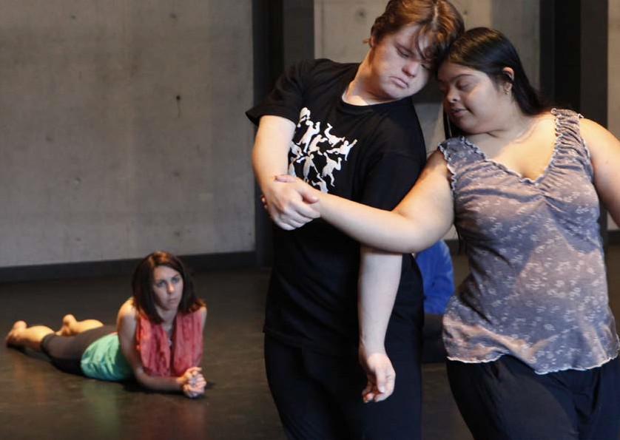

closer than usual and she had chosen to dance with me. It was a moment of transformation.
Two weeks later we danced arm in arm. Her main movement is grabbing and thrusting away.
Her trust has encouraged her to be bold in exploring new movement connections. She surprised herself with her daring as she grabbed at the pockets of my overalls, creating the dungaree dance.

There are safety considerations that a movement practitioner must always remain aware of. One resident is strong and can be aggressive. When we use elastics or therabands, I will
always work with him rather than link him with another resident
as it is possible he will snap the elastic, or yank hard, hurting
the other person. Much of my knowledge of the residents is gained through talking to the
diversional therapists, nurses
and occupational therapists that I
work with at Weemala.

My attitude to my work at Weemala is strongly influenced by the philosophy of teamwork. For a number of weeks I worked all afternoon with two students
in Diversional Therapy and up
to thirty residents in preparation for their disco. The professionals who work at Weemala have great experience and commitment and it is stimulating and rewarding
to work in their team. The importance of good working relations with the staff is crucial
to my ability to work effectively at
Weemala with the residents.

Staffs from the Diversional Therapy team, students and occasionally nurses join our groups. My goal is to create openness, an atmosphere that encourages their creative ideas and active participation in the
movement and storytelling. After the wildly successful disco, all the residents were enthused about karaoke. In our first session after that we had an impromptu story, complete with a microphone where the residents made sounds to the story, an idea initiated by one of the diversional therapists.

It was another member of the team who first took the long, colourful, filmy clothes we use in movement and arranged them in the residents’ hands so that the whole circle of people and wheelchairs was connected together. She also
cleans the urine off the floor so I don’t slip on it if one of the resident’s bags leaks. These mundane moments are part of the creative life at Weemala.

My artistic and movement explorations and storytelling are always intrinsically my own. I
work as a community artist rather
than a dance therapist, and thus work in a creative way, but not in a therapeutic context.

Working in Integrated Dance at Weemala has stretched
the boundaries of my creative performance in depth of feeling and concentration and power. Creative Movement at Weemala is deeply moving in the joy and feeling we experience. Each movement a resident makes
has the potential to be intensely powerful, magnified in its concentration. In these special dances, all the person’s being may be bound up in a hand, a finger, a leg, and the smallest gesture is highly meaningful in its ability to express a person’s whole being. This nourishes
the source of my own creativity. Through their courage and trust I grow in courage and trust,
and dare to go beyond my own perceived limits to express my own creativity.

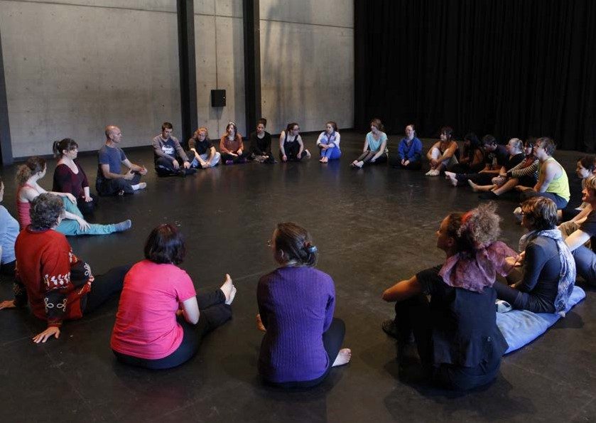

Flying Creatures From
Man to Machine
Catherine Chappell

As I sit here in my office writing this article on my involvement
with Integrated Dance, a beautiful bird feeding off the bright orange flowers of a flame tree distracts me. It is a Tui, a New Zealand native bird, black in colouring, about the size of a pigeon. The male bird bears a white tuft on its neck that it fully extends to drink the nectar. Flying diagonally past my window the Tui disappears from view and is replaced by
two helicopters flying in perfect formation northwards, reminding me that choreography and beauty exist all around us.

Over the past few years flying has become an integral part of my dance work. In our first and subsequent seasons we flew in harnesses attached to ropes, in wheelchairs or on
roller blades. These objects had a life of their own, becoming exciting choreographic tools.
The motion created by the swing
of the ropes, the circling of the wheelchairs and roller blades was exhilarating for the dancers
and audiences alike and became
Touch Compass’ signature.

The purpose of Touch Compass Dance Trust Company is to promote Integrated Dance through performances, community programs, education and training. Touch Compass aims to break down physical and psychological barriers so that
all people who have a passion for dance can do it. Company members are of European, Polynesian and Maori descent, representing the cultural diversity of New Zealand, with ages spanning eight to thirty-five years.

My choreographic process includes giving the dancers
tasks to create material. Dancers work solo or with a partner. This speeds the creative process and allows the whole company to be
involved. The logistics of getting on and off the ropes can impinge on choreographic time, so it has become important to be efficient. Securing ourselves onto the
ropes was not always smooth sailing. It took much practice, skill, patience and courage to have it blend seamlessly into
the show. Working with different abilities can require extra time allocation to achieve the desired result without having to rush and compromise.

Accessibility is an issue for dancers with a disability and those they work with. We rehearsed our first season in
a second-floor studio with no lift. At the time, it seemed the only studio with suitable beams for us to rig our ropes. So
every rehearsal we carried our equipment and dancers up three flights of stairs. The lack of easy access can affect everyone in the company, in rehearsals, touring
and even socialising together. From hotel rooms to theatres that do not have appropriate accessible facilities for both performers and the audience, access issues are always
present. In one theatre, we could only enter and exit from one side of stage, as the wing space was too narrow to accommodate the electric and rugby wheelchairs.

Inevitably, one of the distinct challenges of rehearsing with a mixed group is coordinating with caregivers, taxis and vehicles.
I have found it important to be flexible with scheduling and accommodating each individual’s needs, but at the same time I expect total commitment and professionalism from everyone involved. I accept unavoidable situations; late taxis and health issues but confront anyone who misses rehearsal time due to lack of forethought or planning.

One of the difficulties I have faced over the years has been trying to meet everyone’s
needs – be it that of the dancer, parent, caregiver, the disabled community or the dance community. Finally, I have learnt that this may not always be possible. This has become easier over time, as I have developed a rapport with my dancers and an awareness of what’s possible.

From those early days Touch
Compass is now a trust, has three seasons, two
tours, numerous classes and workshops under its belt and a core group of dancers to call on. Sufficiently established to venture into new choreographic methods and ideas, last year we ran a lab workshop to encourage new choreographers to work with Touch Compass. This offered an opportunity to explore ideas with an integrated company without
the pressure of performance. From this, participants went on to choreograph for the company’s
1999 season, ‘ResinS’. Guy, a company member, choreographed one of the works for ‘ResinS’. Encouraging a
new generation to teach and choreograph, I believe, is vital
to ensure the development and longevity of the work.

In the beginning, when I am getting to know a new dancer I work very much from observation, instinct, compassion and a great expectation that they will be able to achieve whatever I have asked for. Ascertaining each dancer’s abilities and strengths is important. When choreographing I work with
these to extend and challenge each dancer. It may take a little molding and manipulating of the material, but often a new
outcome is more interesting than
the initial intention. Empowering the dancers to create their own movement assists the process and in turn adds their distinctive mark to the work. In a positive sense, I feel I become a director as well as the choreographer.

In both my professional and community work I encourage all the dancers to find as much expression and range of movement for themselves, whether standing, in a chair, on the floor or on the ropes.
I believe that exploring what
is possible, finding new ways to communicate between dancers, developing physical skills and testing one’s limits are important. I love the restrictions of a limitation, then probing
and manipulating to see where it can ‘go’, trying to tap the subconscious to areas yet unexplored.

In our first season Sumara, one of the able-bodied dancers,
commented in an interview:

I had no experience being around people with a disability
I was quite scared I guess, and didn’t know how to relate and communicate at all. Through the work, I did find ways to break down these barriers.
As a company we share the responsibility and spend a lot more time communicating and socialising.

This results in dancers with and without disabilities learning more about each other’s culture, their needs, desires and interests, which inevitably helps the creative process and group bonding.

Some of our dancers have little or no sensation in parts of their bodies. These areas still have blood pumping through them; they are alive but do not receive the correct signals to activate the muscle. Although Rodney

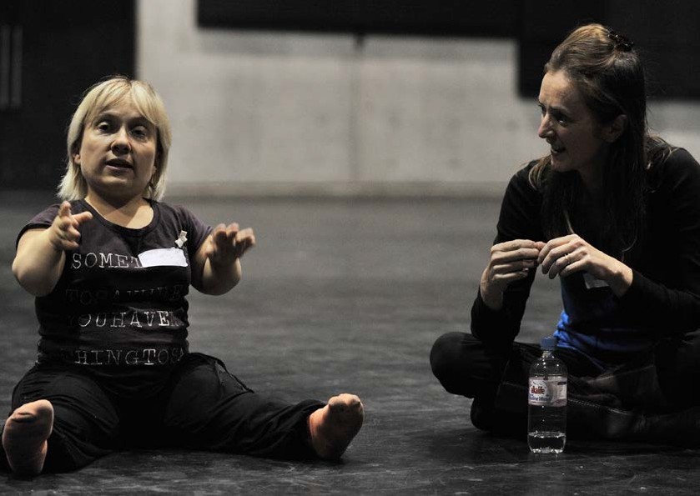

has no sensation in his legs, we try to acknowledge them
as an integral part of him when we choreograph. Providing the members of the company with disabilities the opportunities
to explore and take risks is important, but being aware of possible dangers is also very much a part of the process.

Improvisation is an essential component that Touch Compass uses in rehearsal to develop material. It is also
used in both professional and community performances, either partially, as a structured improvisation, or an entire piece. Our work is informed by Contact Improvisation, which is a democratic form that works with weight, momentum and
flow, reading signals through our skin surface. What excites me working with this form and with Integrated Dance is the depth of communication that is required
between the dancers. It brings with it elements of surprise, connection, risk, beauty and reality.

A constant challenge is how to ensure that all the dancers in an integrated setting are able
to reach their fullest potential. In the Company, I do this through experimentation, reading dancers’ responses to tasks and trying new approaches. In
community classes the mix of the group may dictate whether this happens or not. Some classes have predominantly people with disabilities, which can challenge my aim of full participation. I find
it helpful to know what type of disabilities participants have, as this can affect my planning. Finding the greatest common
denominator is something that I
include in my process.

A common reaction from Touch Compass audience surveys is that what they see
is quite different from their expectations. Presenting a professional production helps facilitate an audience’s full immersion into the choreography. Much of my material includes humour, theatrical elements
and issues that are pertinent to the company. This allows the audience to view the work with an open mind and in the course of a show lose any preconceived notions they may have brought with them.

Accepting and embracing difference is important and encouraging the community to celebrate everyone’s abilities
is part of the message that Integrated Dance brings. We are all made of different parts, but often we only see one aspect of a person.

We still get patronising comments from well-meaning people, such as: ‘Isn’t it wonderful what you are doing,
it must be so amazing for those with disabilities to have this experience’. From my observation, all members of our company have a memorable experience working together. Jesse was the first person
with a disability that I had the pleasure of dancing with. He has Down’s Syndrome and is a truly exceptional dancer who brings the company and audiences much joy, laughter and fine dancing. When the pressure of running this organisation gets too much, Jesse’s sheer passion for dance reminds me why I do it.

Does Integrated Dance have its own aesthetic? Could it be the cultivation of relationships, communication and emotional expressiveness that gives it
an edge? Although this is true of a number of other dance forms, I believe there is a subtle difference that gives texture to an Integrated Dance performance.

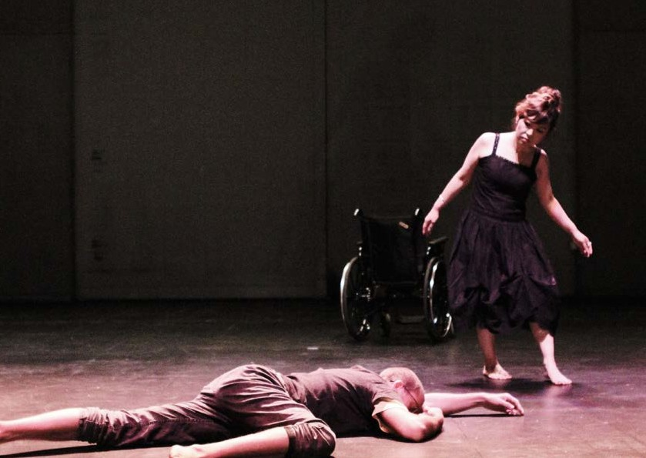
The rich communication that occurs between the dancers and the audience is definitely an essential and alluring factor. Integrated Dance extends my
own perceptions, creativity and ability to communicate with my dancers and the audience.

As for Tui birds and helicopters going about their business creating choreography along
the way, I too am in motion and searching for fuel to sustain
me. As a choreographer I am constantly looking to develop my artistry, at the same time as extending my dancers and challenging perceptions. I am
constantly refining what I want to
say and attempting to find new ways of achieving this, creating dance that transcends people’s expectations, their preconceived ideas and concepts of ‘what is dance’ and ‘who can dance’. There is the saying ‘If you can walk you can dance’. I would extend this to ‘If you can breathe you can dance’.

More Information

View Catherine speaking on Touch Compass and Disability Art.

View Touch Compass performing at The 21st Century Arts Conference 2012.

Dancing In, Over and Out of Wheelchairs
Helen Clarke lapin

Sara Chesterman and Mick Parr talking with Helen Clarke lapin

Sara Chesterman received Australia Council funding and Mick Parr received a Churchill Fellowship to further their studies of dancing in and out of their wheelchairs.

Helen: Why dance?

Mick: I’ve always enjoyed dance and movement, I’ve always had a physical disability, and my body’s always been
a weird shape so I walked differently even when I could walk. A guy came up to me one day as I was swinging my legs as I walked and said, ‘It’s nice watching you walk, you look like you’re dancing’. When I went to watch CandoCo [a mixed ability dance company from England] before I had a wheelchair, I
really liked watching David
Toole dance in and out of his
wheelchair. It made me cry. They were expressing anger
and sexuality which people with disabilities are not expected
to express. I thought, I can do that. I can bring disability out of the closet. I’ve learnt through dance, I think, that I have something to offer.

Sara: I love dance because communication is really important to me. The actual experience of being disabled is a physical thing, so it’s about communicating something of what that reality is. It is not something I have found I can express well in words. It’s something that moves beyond verbal phrases.

Mick: I’d never performed. I’d hidden my body for 30-odd years and suddenly to perform and to put myself in that situation is powerful. I joined Company Chaos [mixed ability
dance company] in Lismore partly to hang out with people with disabilities. They totally accepted me. They just like movement, and each person’s movement is unique.

Sara: I had never encountered someone with a disability before my accident. Then it was a year after my accident
that I was invited to ‘Anybodies Dancing’ Community dance project led by you [Helen] and Janis Claxton. I found it really confronting. I think it was about my fear of being identified as disabled. My body image is so much better since my accident and I remember how worried I was before about my body.

Mick: If we have something to learn in this life, mine is in my body. So many people have tried to change my body. They feel they want to help. But I don’t have a problem
with my body. I actually don’t. If someone asks me about my body before dancing, I say,
‘It is strong, it is robust, you can’t hurt me. I have more fear of hurting you’. I like dance
as a tool. I’m learning all the time about my disability, my difference. But I am also not my disability.

Helen: What about dancing
in a wheelchair? Bruce Curtis wrote in Contact Quarterly, an American journal, that he sees his wheelchair as an extension of his body.

Mick: I love the wheelchair for its smoothness! All my own movements out of the wheelchair were staccato
so I love swirling smoothly in the wheelchair. I remember watching Kim [Mcintyre] dancing with you, Sara. She rolled on you, you were rolling and Kim was rolling somehow around

you on the wheelchair. So Sara was moving, Sara and the wheelchair were moving and Kim was moving, all in contact. So it was like three
things happening at once. The wheelchair itself is hard, jagged and sharp. It is a thing you must get used to dancing with. A guy once said to me, ‘Don’t look
at the wheelchair as a status symbol, use it as a tool’. I like that and that’s exactly what I have done.

Sara: I had been dancing for so long without it, then suddenly I’m dancing in a wheelchair. At first I was really resisting the movement of the wheelchair
and hating its jaggedness and jarring movements. It involved a lot of watching people in class use their legs and going,
OK they’re using their legs, my legs are my wheelchair, so how can I practice with my chair
and develop a technique with
the wheelchair? Everyone’s experience of being in a wheelchair is so different. Mick’s experience in a wheelchair is different to mine because he
can get in and out of it himself. I don’t know two people who are in wheelchairs who have exactly the same level of injury or type
of injury.

Helen: So that speaks for the value of having classes not adapted for you, but open to you finding your own way in.

Sara: Being the only person in a wheelchair in Janis Claxton’s three-month ‘Improvisation and Performance’ training was an amazing experience. Having
a teacher that would say, ‘I have a technique class which is designed for able-bodied people but you can come and do the class and I will provide dancers who are interested
in working with you to adapt
the movement’. Janis would teach a movement phrase to the other dancers and watch how I’d adapt that movement in my wheelchair. Then she would develop a movement phrase based on it. A ‘double
adaptation’ we called it. Seeing my movement reflected back and watching the phrases suddenly move in a whole
new direction was incredibly empowering.

Helen: That fine dance between following and initiating with anybody, with a disability or not, is exhilarating. Doing Contact Improvisation and negotiating an exchange of weight, supporting and being supported by someone in a wheelchair with
the unpredictability of which way the wheelchair will roll, keeps
me very alert and present.

Sara: Dance has been amazing for me in finding the point at
which I’m able to do things independently or where I need support. Exploring where that boundary is, I find amazingly beautiful and it’s helped me
so much to accept that other people are there and enjoy being there.

Helen: In my ‘lnte-Dance’ classes integrating people with and without disabilities, Trish James, who is blind and works for the Royal Blind Society, said she felt there are times when integration is not beneficial. Would either of you have gone to classes that were specifically for people with disabilities, or a class for people in wheelchairs?

Mick: If you’d asked me that the year before last, I don’t know.
But now I would love to work
in a way where everybody who came had to be in a wheelchair whether they needed one or not.

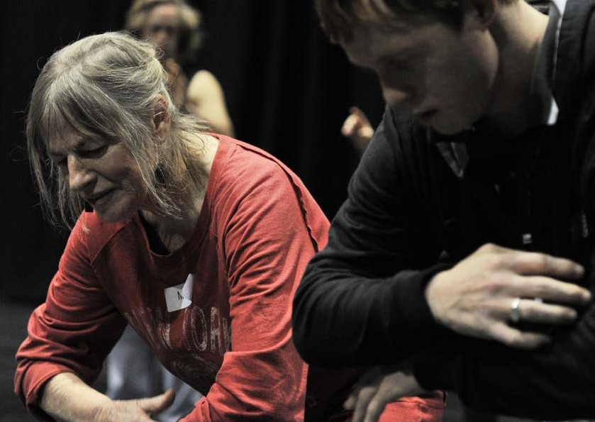

Sara: It doesn’t make sense to me to offer a class just for people with disabilities unless
it is a specific technique class. Say you have a whole group of people in wheelchairs and they want to learn specifically about their body in that wheelchair – that may be a worthwhile class. For me the interesting part is
the connection between people with and without disabilities.

Helen: That brings up an ongoing question for me regarding working in Contact Improvisation when you don’t have the same sensation that I do, and I am assuming that you do. Do you have thoughts about how that could be facilitated with new people dancing with you?

Sara: I think it is really the same techniques that you teach already. It is about waiting and listening and being true to the moment and if you honour that,
I don’t think you can go wrong.
Mick: People often think they’ve got to make the dance happen with people in wheelchairs
rather than just waiting for it to happen. If you’ve got to make the dance happen, you are always going to be pushing and
I know I’ve been in that situation myself, rather than just allowing anything. For me, I don’t feel
that I can be hurt. It feels more like an excuse to say, ‘Oh I can’t feel that’. I feel I’d be trying to explain why I may be clumsy or come down heavily sometimes, or roll off, or something like that. That is where improvisation
is great. A slip from the edge of the wheelchair, a jarring movement, they are all valid.

Helen: How important is performance in what you do?

Sara: It puts me in a state of being in my body that allows me to access a whole lot of emotional and physical realities at the same time. When I have
a lot of people listening to me, giving me their energy, it seems to move me into a different state of mind, which allows me to express something.

Mick: Performance allows people to see things a bit differently. People still speak to me slowly and loudly as if I may not understand them, or they ask whomever I’m with about me. I still hear kids ask their parents, ‘What’s wrong
with Mick?’. And some people say, ‘Oh he’s sick’. I’m not sick! Each person in a wheelchair
has different abilities and you move to the best of your ability.
If you come from the centre, the heart, whatever you call it, the movement will be perfect.

Sara: Performance allows you to choose what you show and to enjoy it. When you are out
on the street you know you are on show but it is still an issue. Oliver Sachs writes about how
invalids are put into homes, they are in valid. You are not supposed to be on show. With the inadequacy of ramps on
the street and public transport, society is basically saying in its physical set-up that you don’t have a right to be there. So performance with people with disabilities is about an audience taking the time to look at you and giving you permission to
be on show.

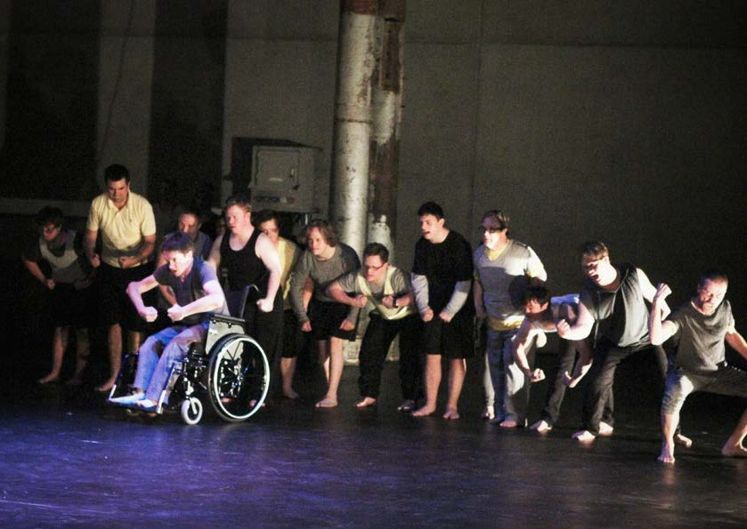

Biographies

Sally Chance
Sally Chance is a dance artist working at the interface between art form and community cultural development. Sally is the founding artistic director for Restless Dance Company. A graduate of the Laban Centre
for Movement and Dance, London, Sally has worked in community and professional dance throughout Australia and the UK. Sally has also worked in India, where she spent a three-month Asialink residency working with people
with disability. Sally has filled the position of Artistic Director for The Australian Festival for Young People, and is Chair of the Australia Council’s Dance Board, where she has also completed
a two year Fellowship. She is currently a board member of the Community Arts Network of SA and the May Gibbs Children’s Literature Trust.
Catherine Chappell
Catherine Chappell has taught at UNITEC, School of Performing & Screen Arts, and guest tutored
at the New Zealand School of Dance and the University of Otago School of Physical
Education. Catherine trained in mixed ability dance with Alito Alessi at the first DanceAbility International Teacher Training in Eugene Oregon. Since then she taught classes for people with and without disability, which led her to be the founder of Touch Compass, New Zealand’s first Integrated Dance Company. In
2011 Catherine was awarded a Creative New Zealand Choreographic Fellowship to research aerial bungee dance in combination with contact improvisation.
Helen Clarke Lapin
Helen Clarke Lapin has a Masters Degree in Dance/Movement Therapy from Antioch University, Masters in Occupational Therapy from Sydney University and is
a certified Yoga Teacher (IYTA). She has taught and performed internationally as a member of Synergy Dance Company and was a founding member of Fulcrum, an improvisational three- member company. In Australia Helen is a leading exponent of Contact Improvisation and has performed with Steve Paxton, founder of Contact Improvisation. Since 1995, Helen has opened her classes to people with and without disabilities. More recently, Helen has been working as a
movement coach for DV8, Stalker Theatre, and for the Accessible Arts Catalyst dance project.
Janice Florence
Janice Florence has completed dance studies in Australia and the USA, including an Arts Degree, Teaching Diploma, Diploma of Librarianship and Graduate Diploma of Movement
& Dance. After becoming paraplegic, she began to develop new directions. Using a grant from the Australia Council, she travelled to the UK to work
with CanDoCo Dance Company. Upon returning to Australia performed and taught in State
of Flux Dance Company based in Melbourne for 10 years. Her involvement in the After Arts Access project developed into
the creation of Weave Movement Theatre in 1997, where she currently fills the role of Artistic Director. Weave is a company
of six performers, both with and without physical disabilities. Janice is currently working in
the role of Access Development Officer for Arts Access Victoria, where she works to expand access to the arts for people with a disability.

Ellin Krinsley
Ellin Krinsley is a community artist sharing story telling and nonstylised movement with diverse groups in Sydney. She has completed a Masters of
Inter-Cultural Performance at the
University of Wollongong.

Jeff Meiners
Jeff Meiners is currently a researcher and lecturer at the University of South Australia’s school of Education. Jeff has taught extensively, directed movement for children’s theatre, and works with government arts and education organizations
and international dance projects. Earlier in Jeff’s career he was
the leader of a dance education team in London. Jeff has worked as manager of Ausdance
New South Wales Outreach Projects, leading projects with young children, youth dance and dancers with disability, and with dance company outreach programs including Australian Dance Theatre, Adelaide, the Dance Xchange, Birmingham, England, and with Forum
Dança in Portugal. Jeff was
Australia Council Dance Board’s Community Representative and in 2009 an Australian Dance Award winner for Outstanding Services to Dance Education. Jeff’s current doctoral research focuses on factors impacting upon the construction and realization of an inclusive primary school dance curriculum.

Andrew Morrish Andrew Morrish has vast experience in performance, teaching and researching in the areas of improvisation, performance and therapy.
Andrew is a Research Fellow at the University of Huddersfield. He has toured internationally as an improvisational dancer with groups such as Neil Thomas’ Urban Dream Capsule, and his movement theatre duet Trotman and Morrish. Andrew has developed various international
collaborative relationships, which allow him to continue to research and perform improvisational performance.
Kat Worth
Kat Worth has a Bachelor of Arts - Dance from the University of Adelaide, has worked as an independent choreographer in Adelaide, Sydney and northern NSW, and as a lecturer at the Northern Rivers Conservatorium Arts Centre. After dancing and teaching with Restless Dance Company, Kat has worked with Integrated Dance in community centres, dance companies, respite programs, festivals and schools. Kat is the founder and previously worked as the Artistic Director of ‘Company CHAOS’ Integrated Dance Movement Theatre Inc. Kat has also worked as Artistic Director of Restless Dance Company, where she developed a movement and music program for young
children with developmental delay. Kat is currently the Director of Whole Body Dance
Movement, providing experience in improvisation, expressive movement and dance for adults, children and babies.
Neridah Wyatt-Spratt
Neridah Wyatt-Spratt is involved in integrated improvisation
and has performed with Isthmus, five women who are exploring movement in aerial and physical theatre. Neridah has worked at Accessible
Arts as a project officer, where she designed, developed and taught inclusive arts programs.

+ –

80

artsaccessaustralia.org aarts.net.au artsaccess.com.au cansa.net.au dadaa.org.au
darwincommunityarts.org.au accessarts.org.au

